**DOMINION UNIVERSITY COLLEGE**

**DESIGN AND IMPLEMENTATION OF LIBRARY MANAGEMENT SYSTEM.**

**BY**

**KRISTOLI YAW AMEVOR**

**Project work submitted to the school of Computing Science and Technology.**

**Dominion university College, in partial fulfillment of the requirements for award of a Higher National Diploma in ICT.**

**2022**

**DECLARATION**

**Candidate’s Declaration**

**I hereby declare that this is the result of my own original research and that no part of it has been presented for another degree in this university elsewhere.**

**Candidate’s Signature………………… Date………………….**

**Name: Kristoli Yaw Amevor**

**Supervisor’s Declaration**

**I hereby declare that the preparation of the thesis was supervised in accordance with the guidelines on supervision of thesis laid down by the Dominion University College.**

**Supervisor’s signature……………. Date…………….**

**Name: Mr. Jessy Anang**

# DEDICATION

This project work is dedicated to the ALMIGHTY GOD for making me being able to start up and finish in sound health. Also, to my parents as well for being supportive in the cause of this project work both financially and spiritually and to my brother and close friends for being supportive and kind to me during the cause of this project work.

# ACKNOWLEDGEMENTS

My sincere gratitude goes to THE ALMIGHTY GOD for his abundant mercies, guidance and protection over me throughout the cause of my project work.

All thanks to my adorable parents Mr and Mrs Adebesin for their profound help and support during the cause of this project work.

I really would say words are not enough to express my profound gratitude to my

SupervisorMrFolorusnhoOlaiya, The Head of Department of Computer Science Dr

Adetunmbi Adebayo, My project coordinator Dr Fagbola T.M, all the Lecturers in the

Department of Computer as well as the Non-teaching Staffs of the Department of Computer Science for their support and inspiration in one way or the other. May God bless you abundantly (Amen).

All thanks to my brothers in the Adebesin family as a whole and my cousin OlusolaOluwasegun (Jago), for their unconditional support throughout the cause of my project work. All thanks to my sincere colleagues in the likes of AlatisheBabajide (Babs),

OladeindeWalihi (Waylahlah), SulaimonSarajudeenOlawale (S.S.O), OyenekanOluwole

Peter (P5), AkinolaBasitOladayor (Alfa), Yaya Ibrahim Adekunle (1 luv), AdegboyeOluwasegun (Obviously) for their immense contribution and unconditional support throughout the cause of my project work. May God in his define favour bless you all (Amen).

# TABLE OF CONTENTS

**Page**

TITLE PAGE i

CERTIFICATION ii

DEDICATION iii

ACKNOWLEDGEMENT iv

TABLE OF CONTENTS v

LIST OF FIGURES ix

ABSTRACT x

**CHAPTER ONE: INTRODUCTION**

1.0 Introduction 1

1.1 Background to the Study1

1.2 Statement of Problem 3

1.3 Aim and Objectives 4

1.4 Purpose of the Study 4

1.5 Scope of the Project 4

1.6 Definition of terms 5

**CHAPTER TWO: LITERATURE REVIEW**

2.0 Literature Review 6

2.1 Introduction 6

|  |  |
| --- | --- |
| 2.2 Development of Library Management System  2.3 Features of Library Management11 | 9 |
| 2.4 Needs for Library Management System | 13 |
| 2.5 Library management system initiatives worldwide | 14 |
| 2.6 Review of Challenges of Library Professionals in developing country  **CHAPTER THREE: SYSTEM ANALYSIS AND DESIGN** | 19 |
| 3.0 System Analysis and Design | 22 |
| 3.1 Introduction | 22 |
| 3.2 Information Gathering | 22 |
| 3.3 Analysis of Existing system | 23 |
| 3.3.1 Problems of Existing system | 23 |
| 3.3.2 Description of Proposed system | 23 |
| 3.3.3 Advantages of Proposed system | 24 |
| 3.4 Design and implementation Methodology | 24 |
| 3.4.1 Software Requirements | 24 |
| 3.4.2 Software tools used | 25 |

3.4.3 Hardware Requirements 28

3.5 System Development Approach 28

3.5.1 V MODEL 29

3.5.2 Requirement analysis and system design 30

3.5.3 Architectural design 31

3.5.4 Module design 32

3.5.5 Validation phases 32

3.6 Dataflow Diagrams 34

3.6.1 Admin login 34

3.6.2 User login 35

3.6.3 Book borrow 35

3.6.4 Book search 36

3.6.5 Account creation 37

3.7 Final Testing 37

**CHAPTER FOUR: SYSTEM IMPLEMENTATION AND DOCUMENTATION**

4.0 System Implementation and documentation 38

4.1 Implementation of the system 38

4.2 Hardware support 38

4.3 Software support 38

4.4 Documentation of the system 39

4.4.1 Program documentation 39

4.4.2 Procedure design 39

4.4.3 Operating system 40

4.5 Input and Output design 40

4.5.1 Home page 40

4.5.2 Admin/User Login 41

4.5.3 Add books 42

4.5.4 Add user 42

4.5.5 Book borrow 43

4.6 Database design 44

4.6.1 User table 44

4.6.2 Borrow book details 45

4.6.3 Book table 45

4.6.4 Member table 46

**CHPATER FIVE: SUMMARY, CONCLUSION AND RECOMMENDATION**

5.0 Summary, Conclusion and Recommendation 47

5.1 Summary 47

5.2 Conclusion 47

5.3 Recommendation 47

**REFERENCES** 48

|  |  |  |  |
| --- | --- | --- | --- |
| **APPENDIX A (Source Code)**  **LIST OF FIGURES** | |  | 50 |
| **Figure** | | **Page** |  |
| 3.1: | V- Model |  | 29 |
| 3.2: | Requirement Analysis | 30 |  |
| 3.3: | Context Diagram |  | 34 |
| 3.4: | Dataflow diagram for Admin login |  | 35 |
| 3.5: | Dataflow diagram for User login |  | 35 |
| 3.6: | Dataflow diagram for Book Borrow |  | 36 |
| 3.7: | Dataflow diagram for Book Search |  | 36 |
| 3.8: | Dataflow diagram for Account creation |  | 37 |
| 4.1: | Screenshot for Home Page |  | 41 |
| 4.2: | Screenshot for Admin/User Login |  | 41 |
| 4.3: | Screenshot for Add books |  | 42 |
| 4.4: | Screenshot for Add user |  | 43 |
| 4.5: | Screenshot for Book Borrow |  | 43 |
| 4.6: | Screenshot for User table |  | 44 |
| 4.7: | Screenshot for Book Details table |  | 45 |
| 4.8: | Screenshot for Book table |  | 45 |

4.9: Screenshot for Member table 46

# ABSTRACT

Library is a collection of sources of information and similar resources, made accessible to a defined community for reference or borrowing. Thus, the process of handling a library manually is very troublesome and clumsy. As regards to this point of view, the computerized system for handling the activities of library management provides a comprehensive way to lessen physical labour, to reduce complexity of the manual system and soon. This project work aims to design and implement a computerized library management system. The library management system was design and implemented using the HTML (Hypertext mark-up language), CSS (Cascading style sheet), PHP (Hypertext pre-processor) and My SQL database. The system was developed using the V-Model software development approach. An extensive evaluation of the project determines that the project achieved many of its predefined objectives.

**CHAPTER ONE**

# 1.0 INTRODUCTION

## 1.1 Background of the Study

A library is an organised collection of information sources which is made accessible to the people. The library usually contains the information physically or in a digitized format. In the olden period the access was usually in the library room as the technology grew up the access that was made online (Dinesh et al.,2015). Library is a fast-growing organism. The ancient methods to maintain it are no longer dynamic and efficient. For expeditious retrieval and dissemination of information and better service for the clientele, application of modern techniques has become indispensable (Neelakandan et al., 2010).

Libraries can be divided into categories by several types, which are: Academic libraries, corporate libraries, Government libraries such as national libraries, Historical society libraries, Private libraries, Public libraries, School libraries, Special libraries, Digital libraries, Picture (photograph) libraries, Slide libraries, Tool libraries, Architecture libraries, Fine arts libraries, Medical libraries, Theological libraries etc.

A library is comprised of the following sections, based on the services rendered.

i. **Acquisition Section**: The books demanded by different departments are done by the Acquisition section. University book centre is also working in this section for supply of books to the libraries in this university. ii. **Technical Section**: To classify, catalogue, OPAC, Barcode etc. the documents of the

University Library this section is working.

1. **Circulation Section**: This section provides documents to the members and users of library for home reading as well as reading in the library. The documents are arranged on the racks in stacks as per the Dewey Decimal Classification Scheme.
2. **Periodical Section**: To procure, maintain and arrange periodicals services to library members. Periodical section provides reference service with respect to the requirement of the reader. Reference section is attached to periodical section for convenience of the library users.
3. **Databases**: Databases like OPAC, CAB-CD ROM abstracting databases, DELNET

online Network Service etc. are available for the library members.

1. **Reprographic Section**: This Section has two automatic plain paper copiers and a duplicating machine through which the services of photocopy are provided to the readers vii. **Binding Section**: This section is working for binding work of the damaged books. Back Volumes and other documents of this Library. The required binding machinery

is available in this section.

Library management is a sub-discipline of institutional management that focuses on specific issues faced by libraries and library management professionals. Library management encompasses normal management tasks as well as intellectual freedom, anti-censorship, and fundraising tasks. Issues faced in library management frequently overlap those faced in management of non-profit organizations (Sharma et al.,2005). Library Management System is an application that portraits library system which could be generally small or medium in size. It is used by the librarian to categorically manage the library by the virtue of using a computerized system where he/she can record various transactions like issue of books, return of books, addition of new books, addition of new students etc. (Ashutosh and Ashish., 2011).

Books and user maintenance modules are also included in this system which would keep track of the users using the library and a detailed description about the books a library contains. With this computerized system there will be no loss of book record or member record which generally happens when a non-computerized system is used. In addition, report module is also included in Library Management System. If user’s position is admin, the user can generate different kinds of reports like lists of users registered, list of books, issue and return reports. All these modules can help librarian to manage the library with more convenience and in a more efficient way as compared to library systems which are not computerized.

This system will be developed and designed to help librarian record every book transaction to reduce and eradicate problem of loss of books and files in the library.

## 1.2 Statement of the Problem

Presently, transaction of books in the institutional libraries have been done manually in most cases, thereby taking more time for transaction like borrowing of books or return of books and searching of member and books. Series of problems occur as a result of this thereby resulting to inefficient library management. In most cases as a result of human error there maybe loss and damages of records due to not using a computerized system in the library.

Nevertheless, the difficulty in the searching of books which could be termed to be inadequacy in book Management is a problem in the manual library thereby causing inefficiency and time consuming in the library. Also, the problem of space consuming erupts after the number of records become large the space for physical storage of file and records also increases if no computerized system is implemented as well as the issue of cost. Due to problem of lack of prompt information retrieval and time wastage in using the library. In addition, due to the cumbersome, in this project computer approach will be used to solve these problems. Each of the manual procedure will be analysed.

## 1.3 Aim and Objectives

The aim of this project is to develop a system that can handle and manage the activities involved in a library in an efficient and reliable way.

The objectives are:

1. Designing a computerized library management system which would help evacuate the problem faced in manual library.
2. Implementing the system.
3. Evaluating and testing the performance of the system.

## 1.4 Purpose of the Project

The main purpose of this project is to develop a computerized system that will manage the activities in the library thereby providing easy access of library usage for librarian and users of the library, it will also help librarians keep track of library information etc. This system will also provide electronic means of storage and help librarians keep track of library information.

## 1.5 Scope of the Project The

project product to be produced is a Library Management System which will automate the major library operations. The first subsystem is the registration of the users to the system to keep track of authorized users to the system. The second subsystem is the registration of new books into the library management system to know when new books are brought into the library. The third subsystem is a borrower and return of books which is the major area needed by the user.

There are three end users for the Library Management System. The end users are the admin, users and members.

## 1.6 Definition of Terms

**Bibliography:** A list of books and articles to be found at the back of many non-fiction books, or at the end of articles in encyclopaedia on the same subject.

**Accession Register:** A book in which the following information about the book is listed when it is obtained: accession number, title, price and source of supply, date of withdrawal and reason for withdrawal.

**Book Card:** A card kept in the pocket of a book when the book is on the shelf.

**Blurb:** Blurb tells what the book is about. It is found either in the front, inside flap of the jacket, or on one of the first few pages of the book or on the back cover.

**Catalogue:** Contain cards with information about each book in the library.

**Contents:** A list in the front of most books (after the title page) which gives the chapter heading or story titles and their page numbers.

**Cataloguing:** The description of each book on to cards as it comes into the library.

**OPAC**: An online public access catalogue is an online database of materials held by a library or group of libraries. Users search a library catalogue principally to locate books and other material available at a library.

**DELNET**: developing library network, is an organisation promoting resource sharing among libraries through the development of a network of libraries.

**CHAPTER TWO**

# 2.0 LITERATURE REVIEW

## 2.1 Introduction

Library is regarded as the brain of any institutes, of course many institutes understand the importance of the library to the growth of the institute and their esteem users which we categorically call the students. Unintegrated library system, also known as a library management system (Adamson et al., 2008) is an enterprise resource planning system for a library, used to track items owned, orders made, bills paid, and users who have borrowed.

The Library Management System is a Library Management software for monitoring and controlling the transactions in a library (Ashutosh and Ashish., 2012). Library Management System supports the general requirement of the library such as the acquisition, cataloguing, circulation and other sections.

Before the advent of computer in modern age there are different methods of keeping records in the library. Records are kept in the library on shelves and each shelf are labelled in an alphabetical or numerical order, in which the categories of books available are arranged on different position on the shelves and as well are recorded on the library manuscript and when any book is to be referenced the manuscript is being referred to, to know the position of such required book by the person that requested for the book. After the invention of computer different researchers have carried out various approach on an automated library management system in which this project is as well all about.

The first library management system to be reviewed is the KOHA library management system. Since the original implementation in 1999, KOHA functionality has been adopted by thousands of libraries worldwide, each adding features and functions, deepening the capability of the system. With the 3.0 release in 2005, and the integration of the powerful

Zebra indexing engine, KOHA became a viable, scalable solution for libraries of all kinds. LibLime KOHA is built on this foundation. With its advanced feature set, LibLime KOHA is the most functionally advanced open-source Integrated Library System in the market today. The major setback of this Library Management System is that it is a web based and as a result it is not security conscious because hackers could have the database hacked and access or modify the information of such user. (www.koha.org).

Another Library Management System is the Capital’s library software with the following benefits Increases support available for staff and users in any modern library service, provides efficiency, innovative system that’s saves library time and improves the user experience.

A library management system usually comprises a relational database, software to interact with that database, and two graphical user interfaces (one for users, one for staff). Most integrated library systems, separate software functions into discrete programs called modules, each of them integrated with a unified interface. Examples of modules might include:

i. Acquisitions (ordering, receiving, and invoicing materials) ii. Cataloguing (classifying and indexing materials) iii. Circulation (lending materials to patrons and receiving them back) iv. Serials (tracking magazine and newspaper holdings)

v. The OPAC (public interface for users)

A library management system usually comprises a relational database, software to interact with that database, and two graphical user interfaces (one for users, one for staff). Most Library Management System separate software functions into discrete program called modules, each of them integrated with a unified interface. Prior to computerization, library tasks were performed manually and independently from one another. Selectors ordered materials with ordering slips, cataloguers manually catalogued items and indexed them with the card cataloguing system (in which all bibliographic data was kept on a single index card), and users signed books out manually, indicating their name on cue cards which were then kept at the circulation desk. Early mechanization came in 1936, when the University of Texas began using a punch card system to manage library circulation. While the punch card system allowed for more efficient tracking of loans, library services were far from being integrated, and no other library task was affected by this change. The literature study in previous system could give more reference in system development process. All the advantages in the previous system can be implemented during the development of this proposed system.

This chapter entails the literature review related to Library Management System initiatives worldwide, at national, regional and international levels. Secondary data will be searched from print and online resources. Foreign literatures will be mainly used and some of these had been highlighted to peruse and emulate.

The purpose of this literature review is to establish the potential topics and suggest ideas for another research, reporting published materials on existing conceptual framework, theories, techniques, processes, styles and instruments of other researchers related to the topic under investigation. It will help analyse scope of study and in determining the various variables to be included.

As for this research, the main purpose of literature review will be to grasp comprehensive ideas on the extent of library management system initiatives and projects that had taken place worldwide and the factors and conditions that had influenced and contributed to their success. The approach to literature review is the browse method where print and electronic sources were looked at, read and digested, looking for some relevancy, appropriateness and usefulness of the topic at hand.

Predetermined keywords to be used during this search are library, virtual library, e-library, hybrid library, library management initiatives, library management problems, library management research, library services, resource sharing, distributed information resources, online databases, library automation, library systems, mobile information access, information professionals, librarian, global access, repositories and interoperability, management systems, library integrated system, database system administration (DBSA).

As the research involves qualitative data as well, research will be made at the initial stage of the research making enquires to get as much primary data as possible from as many librarians as possible whenever there are opportunities to understand the subject better and helped in the formulation of the research questions.

The literature review will be about development of library management system, which is organized into the following sections namely Introduction, Features of Library Management,

Why we need library management system, A Review of Problems and Challenges of Library

Professionals in Developing Countries, Library Management System Initiatives Worldwide (review of library management system).

## 2.2 Development of Library Management System

A library management system is a system for a library resource planning, used to access the documents held, orders, payment or lending all made by the clients. Sometime, a phrase like library integrated system is employed, especially in the UK. Cynthia Lopta defines the integrated system as an automated system in which all the functional modules share the same bibliographic database.

Integration as a concept is most usually found in biblioteconomy. It became a landmark over 20 years ago, and it has grown into an almost synonym for integrated system. Sometimes, integrated refers to a system in which the library functions are processed in a main bibliographic file.

By the mid to late 2000s, library management system vendors not only the number of services offered but also their prices leading to some dissatisfaction among many smaller libraries. At the same time open-source Integrated Library System was in its early stages of testing.

Some libraries began to such open-source integrated library system as KOHA and Evergreen. Most reasons noted from these were to avoid vendor lock in, license fees and participate in software development. The much-needed freedom from vendors also allowed libraries to prioritize need according to urgency, as opposed to what their vendor can offer.

Recently, libraries which have moved to open-source integrated library system have found that vendors are now more likely to provide quality service in order to continue a partnership since they are no longer having the power of owing the Integrated Library System software and tying down libraries to strict contracts. This has been the case with the SC LENDS consortium. Following the success of Evergreen for the Georgia PINES library consortium, the South Carolina States Library along with some local public libraries formed the SC LENDS consortium in order to share resources and to take advantage of the open-source nature of the Evergreen Integrated Library System to meet their specific needs.

By October 2011, just two years after SC LENDS began operations, thirteen public library systems across 15 counties had already joined the consortium in addition to the south Caroline State Library. Librarytechnology.org does an annual survey of over 1,500 libraries and noted in 2008, 2 % of those who surveyed use the Integrated Library System, in 2009 the number increased to 8% and in 2010(most recent year available) 12% of the libraries polled had adopted open-source Library Management System.

Library project system that offers many flexible and convenient features, allowing librarians and library users to maximize time and efficiency. Library system gives all the detailed information about students, staffs and books, it will track the books available in the library and the books that have been issued to the library users (students). It shows popular books among the students. It will provide book lost in the library. It keeps records of the supplier and the book binders.

## 2.3 Features of library management

1. Manage Book and Member Record with help of Barcode.
2. Acquisitions: With library Management software, Acquisitions function as generate Purchase order, Cancel Purchase Order, Reminder Purchase order, Receive Purchase Order, Invoice and instantly available in Reports . Data can be search by feeding Purchase Order number, Invoice number, and Supplier name. iii. Circulation: Library Management Software enables the complete management of multiple Item issue and return of books using Manual or Barcode Scanner.
3. Barcode: Use of Bar Codes for Library Management eases the everyday tasks of big Libraries, where the No. of transactions exceed several thousands in number.

Moreover, the software can work even without Bar Codes seamlessly. The Barcode generation and printing process is a Built-In feature of this Software.

1. OPAC: Library management software admin/Member can easily search book.

author, Title, Accession No, Publication, and Language also admin can filter data with category wise.

1. Facility for User to suggest items: User suggestion and request for purchasing a new item is handled by the software itself reducing the administrator’s task.
2. Alert through Email: Admin can send mail to members, vendors, or any other people from the software.
3. Multiple Library Setup: Library management software can setup at different locations.
4. Export All Report into Excel, Word: Admin can take all the details which are displayed in the reports into excel and word file.
5. Handles donated items, free items and keep track of donors: Some library items are free, or some person donates the item. So, Library management software keeps track of those items.
6. Provide Multi: User environment: Library management software gives facility of multi: user environment. Multiple users can login at the same time in the library. management software.
7. Maintain Any Media: one can define a few things that one wants to keep track of as well as can maintain different kinds of media like Book, CD, File Documents, Video Cassette, and Audio Cassette. Also, one can maintain media with its own specifications rather than common and define the specification you want for that media, for book (pages, ISDN number, type, volume).
8. Powerful Search Engine
9. . Custom Field Indices: Library Software provides sorted data on required fields by clicking on the column header that is if clicked on publisher the data will be sorted on publisher.
10. Lock System: Lock the subject or group of the member, so that media can't be issued which falls under these criteria. One can in this way restrict the issuing of the media.
11. Circulation: Easy operation of circulation by entering the code of media, get all the information related to the media and the number. (Name, group, media type). xvii. Easy Navigation and Updating**:** Selecting an option from the given menu provide

all the data related to that option in tabular format in a user-friendly manner. xviii. Auto Filter & Auto Search: On each master form, Library Software will search on

the field where your cursor is and what you type is taken as a search value.

1. Customize: one can customize the system to feel easier for data entry also while adding records user can keep form in 'add' mode. Define Holidays. And set the criteria of issuing the book if member is requested for media or not.
2. Scrap-Type: Define their own scrap type for scraping the media. Provides scrap runner utility to record the number of scrap media.
3. Reports

## 2.4 Needs for library management system

i. Improved customer services through greater access to accurate information ii. Increased productivity and job satisfaction among staff members as it eliminates duplication of effort iii. More economical and safer means of storing and keeping of information iv. Easier access to information like management reports and stock etc. as well as

accurate and faster results from statistical analyses.

v. Reduces errors and eliminating of ennui of long and repetitive manual processing vi. Greater accountability and transparency in operations vii. Improved efficiency and effectiveness in administration and management as it has unprecedented access to real- time information.

1. More reliable security for sensitive and confidential information.
2. Appropriate knowledge –based action and intervention can now take place in a timelier manner.

## 2.5 Library management system initiatives worldwide

Neelakandan, Duraisekar, Balasubramani, and Srinivasa, (2010) in their study developed a system using KOHA Open source software to develop an updated database of books and other resources of the school of Chemistry Library, Bharathidasan University to implement automated system using KOHA library integrated Open source software to carry out the charging and discharging functions of the circulation section more effectively which provide various search options to know the availability of books in the library to generate the list of books due by a particular member and also the overdue charges. KOHA is being said to be an integrated software system with all the required models for small to very large libraries (Neelakandan et al., 2010).

The outcome of the system they developed has: Chemistry library collections that are in single database, it gives the full control over the library collections and operations, faculty members search and research scholars can check the required books by OPAC modules, research scholars and faculty members can check the status of their borrowed books, they can get the complete details about the books for their further reading and research, data entry of the books can be done through the downloading of bibliographic details from the library of congress and other catalogues and the library system developed can share their data with various library and other department in the libraries.

The limitations of his research were based on:

I. Lack of Infrastructure facility ii. Lack of Environment support iii. Lack of Financial Resources

Koy yeeh keat, (2011) in his research developed a library management system which could be mainly used by member and staff of the library. The system allows members search for books and reserve books through website so that they can save their time and cost to travel from one place to another to use the library as well as know what the book entails in the library. In the system developed, staffs can also be able to add news and view reports with several criteria as well as add, edit and delete news. The system developed was aimed at allowing users to reserve books via online, to convenient user borrowing books via online, implementing email technologies to the website, implementing SMS technologies to the system, designing a friendly graphical interface which would suit the users.

In the designing of the system, various modules were considered which are the:

i. Authorization and authentication module ii. Member/staff module iii. Search module iv. Books maintenance module

v. News maintenance module vi. Email module vii. Report modules

viii. Publisher maintenance module ix. Employee maintenance module etc.

The software used in the research entails the use of Microsoft products like the Microsoft visual studio 2008 for the website development and ASP.NET with C# as the programming language used having the Microsoft SQL server 2008 as the database. Mainly the software and hardware requirement used in his research were:

i. Operating system: windows 7 professional ii. Database: MYSQL server 2008 iii. Development tools and programming language: Microsoft visual studio 2008 and

VB.NET

1. Processor: Intel core i2 duo CPU T7250 @ 2.00 GHz
2. Ram: 2 GB

The methodology used in the research was the waterfall model which entails the system planning, requirement analysis, system design, programming, system testing and the evaluation.

Ashutosh Tripathi, and Ashish Srivastaval, (2012) developed a system which is a library management software for monitoring controlling the transactions in a library. In their study they came up with a Library Management System which was developed in java and mainly focuses on basic operations in a library like adding new member, new books, and updating new information, searching books and members and facility to borrow and return books.

The system these two developed was an automated Library Management System. In which through the software user can add members, add books, search members, search books, update information, edit information, borrow and return books in quick time. The system they developed has the following advantages.

User friendly interface, Fast access to database, less error, More Storage Capacity, Search facility, Look and Feel Environment

All the manual difficulties in managing the library were rectified by implementing computerization. The software which was designed can help users maintain and organize library making the software very easy to use for both beginners and advanced users.

The system requirement for the research entails how the library management system that was designed can be used in windows 98 Windows2000, Windows XP and Windows NT, supported for another platform such as Applet Macintosh and UNIX. The system was made to run on Windows 98 or Windows NT4.0 operating system and met the following hardware requirements.

I. For Windows 95 based computers, a 486 / 66 MHz or higher processor with 8MB ii. For Windows 98 based computers, a 500/88MHz or higher processor with 32 Mb of

RAM

iii. For Windows NT based computers, a 488 / 66 MHz or higher processor with 16 MB of RAM iv. For Windows 200 based computers, a 700/850 MHz or higher processor with 512 MB of RAM

At the end of his research the combination of all the web pages he designed resulted in a web application named Library Management System, which works as online library. Several user-friendly coding was also adopted.

Prabhakar kumar, Rahul Kumar, Rajat Singh and Vikram Singh, (2014) developed a library management system which aims in developing a computerized system to maintain all the daily work of library. By the virtue of their research work, the system developed entails many features which are generally not available in normal library management systems like facility of user login and a facility of teacher’s login. The system developed also has a facility of admin login through which the admin can monitor the whole system etc. the objectives of the system developed was aimed at:

1. Improvement in control and performance.
2. Save cost. iii. Save time.

iv. Option of online Notice board where Librarian will be able to provide a detailed description of workshops going in the college as well as in nearby colleges etc.

The software and hardware requirement in the designing of the system were:

I. Operating system- Windows 7 ii. Database - MYSQL-MYSQL

iii. Development tools and Programming language- HTML was used to write the whole code and develop webpages with CSS, java script for styling work and PHP for sever side scripting. iv. Intel core i5 2nd generation is used as a processor.

v. Ram 1 GB

Sarawut Markchit, (2015) developed a system to identify the problem and obtain necessary requirements data from the librarians, analyse the obtain data, design and develop the system and conduct an assessment or survey from the users of library resources service through websites and mobile systems with web services with regards overall performance of Suratthani Rajabhat University Central Library.

Sarawut Markchit system was able to acquire material as quickly as possible, maintain a high level of accuracy in all work procedures, and keep work processes simple, in order to achieve the lowest possible unit cost and develop close, friendly working relationships with other library units and vendors.

In his methodology he was able to make use qualitative methods using structured interviews. Information were being gathered by the virtue of this.

The system was developed using some instruments used for the development which were visual studio .NET (ASP.NET) for web-based application, HTML5 for mobile application, web-service for data communication with the component and connected to staff system of this University, Microsoft SQL server for database management and longest matching algorithm for data retrieval.

## 2.5 Review of Problems and Challenges of Library Professionals in Developing Countries

New tools of information technology have absolutely changed the role & responsibilities of librarians. A few studies have been conducted to explore the problems faced by librarians. Given section reviews the studies conducted at international level in general and particularly in developing countries to investigate the problems confronted by the librarians.

Adomi and Anie, (2006) in their research on computer literacy skills of professionals in Nigerian University libraries concluded that most of the professionals do not poses high level of computer skill and their use of computer and technology is still maturing. They recommended that library management and leaders should organize and offer in-house computer training programmes for librarians and enough computers should be provided in this regard.

Johnson, (2007) viewed library and information science education in developing countries. He concluded that LIS programs in developing countries continue to suffer from lack of financial support by governments.

Rahman, Khatun and Islam, (2008) reviewed the library education in Bangladesh. The study found that majority of institutions in Bangladesh do not have well-equipped computer labs or enough computers for students. Enough classification and cataloguing tools (DDC, LC, Sears list of subject headings for practical were not present. Many institutions either have no library or inadequate collection of textbooks. Professional’s status was also found very low, low pay scale and limited opportunities for promotion. In Nepal, Siwakoti, (2008) found that there was no government agency to control, monitor and evaluate the school libraries activities. There was lack of awareness programs, budgetary constraints, inadequate space, inadequate library materials, lack of trained and skilled manpower and lack of appropriate government policy and lack of information literacy.

Ademodi and Adepoju, (2009) investigated the computer skill among librarians in academic libraries on Ondo and Ekiti State in Nigeria. It was found the shortage of computers and computer skills among professionals. The study recommended that more attention and funds should be provided for training and procurement of ICT infrastructure in Nigerian University libraries. For computerization purpose, library administration should solicit funds and assistant from foreign agencies and foundations who are interested in the cause.

Dasgupta, (2009) searched out that in India there is non-existent of norms and standards for the education of librarians. Problems for Indian librarians discovered in his study were emergence of new Library Integrated System schools, insufficient faculty strength, and lack of accreditation bodies, lack of proper library facilities, inadequate physical facilities, little attention for selection criteria, and lack of apprenticeship programs. Study suggested that the Government of India should play a leading role in promoting LIS education in India, by creating more job opportunities for LIS professionals and removing disparity in pay scales among LIS professionals.

In Iran Gavgani, Shokraneh and Shiramin, (2011) concluded that librarians do not have traditional skills and sufficient background knowledge to meet the changing needs of their customers. They need to be empowered by new skills and information before going to empower their patrons. So, there must not be a gap between librarians’.

professional/technological knowledge and their societies informational need that to be answered by librarians. Need for changing the syllabus of medical library and information science education in Iran was also felt.

**CHAPTER THREE**

# 3.0 SYSTEM ANALYSIS AND DESIGN

## 3.1 Introduction

To develop a best fit system to the library, there are three stages of developing the new system. They are gathering information, design and implementation and final testing. Within these three sections, different tactics will be adopted so that we can design a system that can maintain high usability and accessibility. Below are some ideas to the process.

## 3.2 Information Gathering

Before setting up the system by software development tools, information will be gathered from the staff about the need for the users of the system like the staff of library and those readers by using qualitative gathering techniques (oral interviews). Before starting to implement the system, interviews will be made to get readers view on the system before having the design works being done.

After considering the scope and the objectives of this study, it is very much ideal to use the qualitative gathering techniques method i.e., the survey method, using the oral interview.

Interviews would be done to investigate and identify the scenario that libraries were going through in embarking on automation projects having embraced library automation.

The library is a major means of data gathering and as well a case study for the proposed system. In line with this the major method of information gathering for the system is the library and observation method via observing the staff and operation of the library.

## 3.3 Analysis of Existing System

The existing system of library management system involves lots and lots of paperwork. The system involves that all library user details will be taken on a white and black method. To borrow book from a library a borrower information is being taken for every registered user and can sign out for return of the book once he/she is completed.

### 3.3.1 Problems of existing system

Having have the overview knowledge of the existing system, the following are its problem.

1. Loss of Data: A lot of paper works are needed for the safe keeping of the details of books borrowed by a registered user.
2. Time Wasting: User time are wasted as a result of searching for a book that has been borrowed by a user whose record cannot be traced on the paper records.
3. Error Prone: The existing system of operation is prone to error.
4. Tedious: It is tedious because it must take a routine
5. Processing Speed: The processing speed is very low resulting into low output.

### 3.3.2 Description of Proposed system

The library management system is a desktop-based application system used by an administrator (Librarian) as an alternative means of record keeping of the books stored in the library. It has the following features.

I. The administrator registers the applicant with their name as the first and last name, matriculation number, department etc. and a username is being suggested by the user alongside a login password which is to be used for logging in by the registered user ii. An applicant is allowed to log into the system with his name and generated password which is given at the point of registration.

iii. The administrator goes into the report to view the details of a particular user.

### 3.3.3 Advantages of Proposed system

Certain merits have been associated with the proposed system which enhances the design of the system. Some of which are stated below:

1. It eliminates the presence of the audience or fellow colleague who can whisper the

result to their friends.

1. It is free from biasness (all users are served equally). iii. It provides an immediate form of response to every user. iv. It facilitates easy learning.

## 3.4 Design and Implementation Methodology

The design methodology used in the proposed system is parallel as a result of the fact that parallel methods support the use of the proposed system side by side with the existing system in order to test for the system efficiency. Top-down approach is used as well in the design because it allows the analysis of the system to be carried out one after the other.

In this stage, the first goal will be decided by task analysis. Next, the prototype of the system will be analysed. Then test will be made on its usability and design with some design theories. Thus, the prototype will be correspondingly looked at. Then a more complete prototype will be tested by potential users to collect feedbacks. Finally, the system will be finalized with the amendment on some problems of the user interface.

### 3.4.1 Software Requirements

i. Operating system- Windows 8 is used as the operating system as it is stable and supports more features and is more user friendly ii. Database MYSQL-MYSQL is used as database as it easy to maintain and retrieve records by simple queries which are in English language which are easy to understand and easy to write.

Development tools and Programming language- HTML is used to write the whole code and develop webpages with cascading style sheet, java script for styling work and hypertext pre-processor (PHP) for sever side scripting.

### 3.4.2 Software tools used.

The whole Project is divided in two parts the front end and the back end.

**FRONT END:** The front end is designed using of HTML, PHP, CSS, Java script.

1. HTML- HTML or Hyper Text Mark-up Language is the main mark-up language for creating web pages and other information that can be displayed in a web browser.HTML is written in the form of HTML elements consisting of tags enclosed in angle brackets (like <html>), within the web page content.

The purpose of a web browser is to read HTML documents and compose them into visible or audible web pages. It provides a means to create structured documents by denoting structural semantics for text such as headings, paragraphs, lists, links, quotes and other items. It can embed scripts written in languages such as JavaScript which affect the behaviour of HTML web pages.

1. CSS- Cascading Style Sheets (CSS) is a style sheet language used for describing the look and formatting of a document written in a mark-up language. While most often used to style web pages and interfaces written in HTML and XHTML, the language can be applied to any kind of XML document, including plain XML, SVG and XUL. CSS is a cornerstone specification of the web and almost all web pages use CSS style sheets to describe their presentation.CSS is designed primarily to enable the separation of document content from document presentation, including elements such as the layout, colours, and fonts.

This separation can improve content accessibility, provide more flexibility and control in the specification of presentation characteristics, enable multiple pages to share formatting, and reduce complexity and repetition in the structural content (such as by allowing for table less web design).CSS can also allow the same mark-up page to be presented in different styles for different rendering methods, such as on-screen, in print, by voice (when read out by a speech-based browser or screen reader) and on Braille-based, tactile devices. It can also be used to allow the web page to display differently depending on the screen size or device on which it is being viewed.

1. JAVA SCRIPT- JavaScript (JS) is a dynamic computer programming language. It is most used as part of web browsers, whose implementations allow client-side scripts to interact with the user, control the browser, communicate.

asynchronously, and alter the document content that is displayed. It is also being used in server-side programming, game development and the creation of desktop and mobile applications. JavaScript is a prototype-based scripting language with dynamic typing and has first- class functions. Its syntax was influenced by C. JavaScript copies many names and naming conventions from Java, but the two languages are otherwise unrelated and have very different semantics. The key design principles within JavaScript are taken from the self and Scheme programming languages. It is a multiparadigm language, supporting object-oriented, imperative, and functional programming styles.

1. PHP- PHP is a server-side scripting language designed for web development but also used as a general-purpose programming language. PHP is now installed on more than 244 million websites and 2.1 million web servers.

Originally created by Rasmus Lerdorf in 1995, the reference implementation of PHP is now produced by The PHP Group. While PHP originally stood for Personal Home Page, it now stands for PHP: Hypertext Pre-processor, a recursive backronym. PHP code is interpreted by a web server with a PHP processor module, which generates the resulting web page: PHP commands can be embedded directly into an HTML source document rather than calling an external file to process data. It has also evolved to include a command-line interface capability and can be used in standalone graphical applications. PHP is free software released under the PHP License. PHP can be deployed on most web servers and as a standalone shell on almost every operating system and platform, free of charge.

**BACK END-** The back end is designed using MySQL which is used to design the databases.

I. MYSQL- MySQL ("My S-Q-L", officially, but also called "My Sequel") is (as of July 2013) the world's second most widely used open-source relational database management system (RDBMS). It is named after co-founder Michael Widenius daughter, My. The SQL phrase stands for Structured Query Language. The MySQL development project has made its source code available under the terms of the GNU General Public License, as well as under a variety of proprietary agreements. MySQL was owned and sponsored by a single for- profit firm, the Swedish company MySQL AB, now owned by Oracle Corporation. MySQL is a popular choice of database for use in web applications and is a central component of the widely used LAMP open-source web application software stack (and other 'AMP' stacks). LAMP is an acronym for "Linux, Apache, MySQL, Perl/PHP/Python." Free-software-open-source projects that require a full-featured database management system often use MySQL. For commercial use, several paid editions are available, and offer additional functionality.

Applications which use MySQL databases include: TYPO3, MODx, Joomla, WordPress, phpBB, MyBB, Drupal and other software. MySQL is also used in many high-profile, large-scale websites, including Wikipedia, Google (though not for searches), Facebook, Twitter, Flickr, and YouTube.

### 3.4.3 Hardware Requirements

1. Intel core i5 2nd generation is used as a processor because it is fast than other processors and it is very reliable, and we can as well run our pc for long time with the Intel core i5. By using this processor, we can keep on developing our project without any worries.
2. Ram 4 GB is used as it will provide fast reading and writing capabilities and will in turn support in processing.

## 3.5 System Development Approach

System development life cycle is referred to a methodology for developing systems. It produces a consistent framework of tasks and deliverables needed to develop systems. The SDLC methodology may be condensed to include automated or manual, whether it is a new system, or an enhancement to existing system. The SDLC methodology tracks a project from an idea developed by the user through feasibility study, systems analysis and design, programming, pilot testing, implementation and post implementation analysis,

The development methods that intend to use for the library management system is the V model which may be considered as an extension of the waterfall model, it offers a mean of making the development process more visible. A system prototype can be developed to give end-user a concrete impression on the system capabilities. System life cycle is an organisational process of developing and maintaining systems, its helps in establishing a system project plans because it gives overall list of process and sub processes required developing a system.

System development life cycle means combination of various activities. In other words, various activities put together are referred to as system development life cycle. In the system analysis and design terminology system development life cycle is known to be software development life cycle, the following are the different phases of software development life cycle.

Software concept, Requirement analysis, Architectural design, Coding and debugging,

System testing, Implementation, Maintenance.

### 3.5.1 V - MODEL

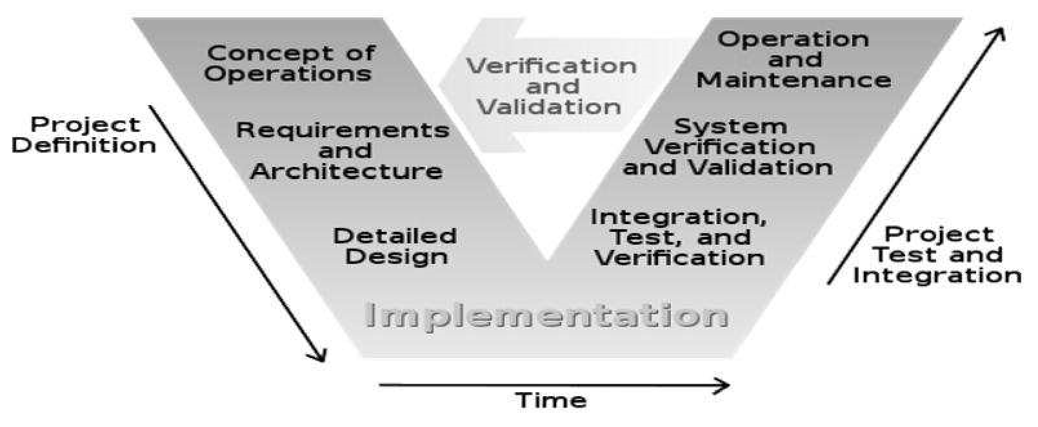

Figure 3.1: V-model

In theRequirements analysisphase, the first step in the verification process,

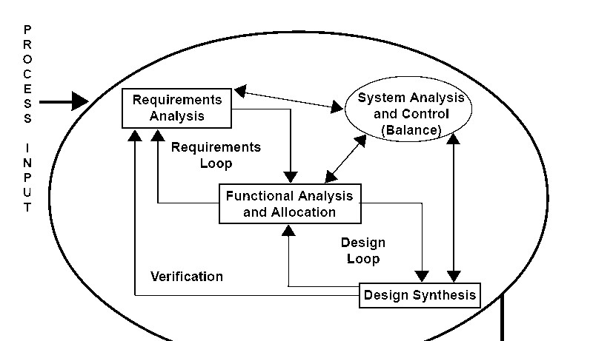

The V model represents a software development process (also applicable to hardware development) which may be considered an extension of the waterfall model. Instead of moving down in a linear way, the process steps are bent upwards after the coding phase, to form the typical V shape. The V-Model demonstrates the relationships between each phase of the development life cycle and its associated phase of testing. The horizontal and vertical axes represent time or project completeness (left-to-right) and level of abstraction (coarsest grain abstraction uppermost), respectively.

### 3.5.2 Requirement analysis and system design

The requirements of the system are collected by analysing the needs of the user(s). This phase is concerned with establishing what the ideal system must perform. However, it does not determine how the software will be designed or built. Usually, the users are interviewed, and a document called the user requirements document is generated.

The user requirements document will typically describe the system’s functional, interface, performance, data, security, etc. requirements as expected by the user. It is used by business analysts to communicate their understanding of the system to the users. The users carefully review this document as this document would serve as the guideline for the system designers in the system design phase. The user acceptance tests are designed in this phase. There are different methods for gathering requirements of both soft and hard methodologies including interviews, questionnaires, document analysis, observation, throw-away prototypes, use cases and static and dynamic views with users. The requirement documentation will be referred throughout the rest of the system development process to ensure the developing project along with the need and requirements.

Systems design is the phase where system engineers analyse and understand the business of the proposed system by studying the user requirements document. They figure out possibilities and techniques by which the user requirements can be implemented. If any of the requirements are not feasible, the user is informed of the issue. A resolution is found, and the user requirement document is edited accordingly. The software specification document which serves as a blueprint for the development phase is generated. This document contains the general system organization, menu structures, data structures etc. It may also hold example business scenarios, sample windows, reports for the better understanding. Other technical documentation like entity diagrams, data dictionary will also be produced in this phase. The documents for system testing are prepared.

### 3.5.3 Architectural design

The phase of the design of computer architecture and software architecture can also be referred to as high-level design. The baseline in selecting the architecture is that it should realize all which typically consists of the list of modules, brief functionality of each module, their interface relationships, dependencies, database tables, architecture diagrams, technology details etc. The integration testing design is carried out in the phase. After the requirements have been determined the necessary specifications for the hardware, software and people and data resources and the information products that will satisfy the functional requirement of the proposed system can be determined. The design will serve as a blueprint for the system before these errors or problems are built into the system.

### 3.5.4 Module design

The module design phase can also be referred to as low-level design. The designed system is broken up into smaller units or modules and each of them is explained so that the programmer can start coding directly. The low-level design document or program specifications will contain a detailed functional logic of the module in pseudo code:

1. Database tables, with all elements, including their type and size.
2. All interface details with complete API references. iii. All dependency issues. iv. Error message listings.

v. Complete input and outputs for a module.

The unit test design is developed in this stage.

### 3.5.5 Validation phases

In the V-model, each stage of verification phase has a corresponding stage in the validation phase. (De spautz et al., 2008) The following are the typical phases of validation in the V Model, though they may be known by other names.

1. Unit testing

In the V-Model, Unit Test Plans (UTPs) are developed during module design phase. These UTPs are executed to eliminate bugs at code level or unit level. A unit is the smallest entity which can independently exist, e.g., a program module. Unit testing verifies that the smallest entity can function correctly when isolated from the rest of the codes/units.

1. Integration testing

Integration Test Plans are developed during the Architectural Design Phase. These tests verify that units created and tested independently can coexist and communicate among themselves. Test results are shared with customer's team.

1. System testing

System Tests Plans are developed during System Design Phase. Unlike Unit and Integration

Test Plans, System Test Plans are composed by client's business team. System Test ensures that expectations from application developed are met. The whole application is tested for its functionality, interdependency and communication. System Testing verifies that functional and non-functional requirements have been met. Load and performance testing, stress testing, regression testing, etc. are subsets of system testing.

1. User acceptance testing

User Acceptance Test (UAT) Plans are developed during the Requirements Analysis phase. Test Plans are composed by business users. User Acceptance Testing is performed in a user environment that resembles the production environment, using realistic data. User Acceptance Testing verifies that delivered system meets user's requirement and system is ready for use in real time.

## 3.6 Data flow diagrams

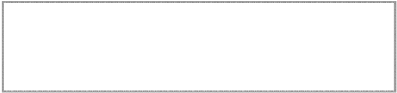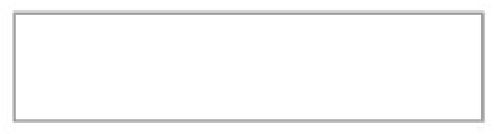

Homepage

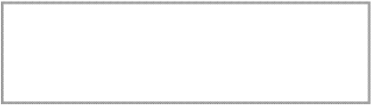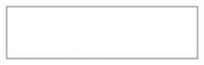

About

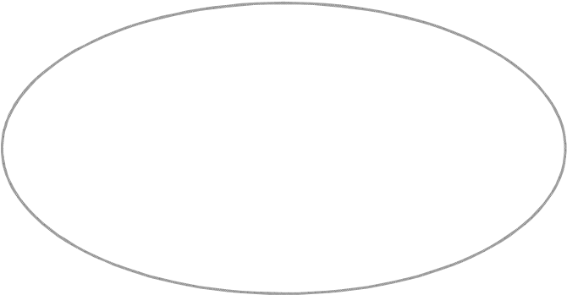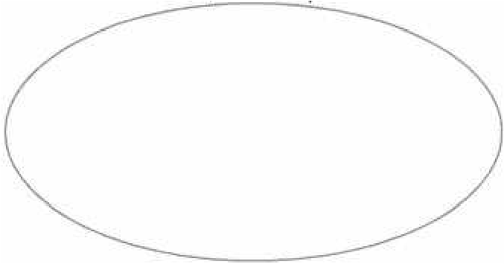

Library Management

System

Admin login User login

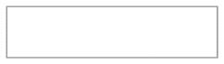

User

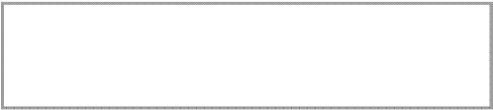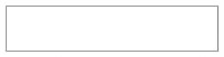

Admin

Figure 3.3: Context diagram

### 3.6.1 Admin login

|  |
| --- |
| HOME |

After entering to the home page of the website, librarian can choose the ADMIN LOGIN option where they are asked to enter username and password, and if he/she is a valid user then a login page will be displayed.

USER

LOGIN

ENTER

USERNAME

AND

PASSWORD

CHECK

VALIDITY

USER DATABASE

HOME

ADMIN

LOGIN

ENTER

USERNAME

AND

PASSWORD

CHECK

VALIDITY

ADMIN LOGIN

PAGE

ADMIN

DATABASE

WEB SERVER

Figure 3.4: Dataflow diagram for admin login

### 3.6.2 User login

After entering to the home page of the website, user can choose the USER LOGIN option where they are asked to enter username and password, and if he/she is a valid user then a user login page will be displayed.

USER LOGIN

PAGE

WEB SERVER

Figure 3.4: Dataflow diagram for user login

### 3.6.3 Book borrow.

The book borrow Data Flow Diagram is the one where after entering USER LOGIN page he/she can select a book borrow option where after entering the book detail, he/she can select the book borrow option and if the maximum no of books borrowed limit is not crossed then a book can be borrowed. A certain user is entitled to borrow three maximum books at a time else the user cannot borrow more than. In the borrowing of books a user will be prompt with the due date.

USER LOGIN

PAGE

SELECT

BOOK

SEARCH

BOOK

BORROW

ER NAME

BORRO

W

BOOK

DATABASE

LOGIN

TABLE

BOOK

DATABASE

LOGIN

DATABASE

Figure 3.5: dataflow diagram for book borrows.

## 3.6.4 Book search

After the home page login there will be an option of the book search where after entering book detail like author name, publication, book name etc. book details will be displayed.

HOME

SLECT

ADVANCE

SEARCH

ENTER

BOOK

DETAIL

BOOK

DETAILS

BOOK

DATABASE

Figure3.6: Dataflow diagram for book search

## 3.6.5Account creation

After the home page login there will be an option of CREATE AN ACCOUNT where after entering student detail, if all the fields are filled then a request will be sent to the librarian who will approve him as a registered member of the library.

HOME

SELECT

ADMIN

ENTER

ADMIN

DETAILS

ADMIN

CREATE

USER

ACCT

USER

LOGIN SET

ADMIN

DATABASE

USER

DATABASE

Figure 3.7: Dataflow diagram for account creation

### 3.7 Final Testing

When the product is finalized, it will be run on a real-world environment and test on its performance. If the performance is satisfactory, it will be applied, else amendment will be made to correct the problems. After the system has been run for daily operation, continued maintenance and administration should be carried out to handle any system errors and security issues.

This will entail the pre-test, validity test, pilot and reliability test and the data survey.

**CHAPTER FOUR**

# 4.0 SYSTEM IMPLEMENTATION AND DOCUMENTATION

## 4.1 Implementation of the System

This describes how the system works and how best computers together with other resources may be applied to perform data storage, management and retrieval for decision making. The requirement of this research work demands a web programming language.

## 4.2 Hardware Support

The hardware that is required in the successful completion of this project include.

1. A system running on Pentium 2.
2. A random-access memory (RAM) of 512 MB. iii. Enhanced Keyboard. iv. V.G. A or a coloured monitor.

v. A 2.0 GB hard disk.

## 4.3 Software Support

The software support for the design of the proposed system involves:

i. A windows 8 operating system. ii. Macromedia Dreamweaver. iii. WAMP server. iv. My SQL database.

v. An internet access as well as an anti-virus software which prevents the system from being infected by virus.

## 4.4 Documentation of the System

### 4.4.1 Program Documentation

For the proposed system to be used on any computer system it takes the following ways:

1. Boot the system.
2. Install the WAMP server.
3. Turn server on (Active). iv. Copy the folder to www inside WAMP folder of the drive C: after WAMP server is installed on the system.

v. Open any browser on the system (Microsoft internet Explorer, Mozilla Firefox,

Netscape Navigator, Opera, Flock, Safari etc.) vi. Type http://localhost/duclms/index.php on the address bar and press the return key or enter key.

## 4.4.2Procedure Design

This refers to the step-by-step method of using the proposed system. The proposed system comprises of Administrator and the general user environment. The steps to use the proposed system are as follows:

i. On the address bar of any browser type http://localhost/fuoyelms/index.php ii. You are prompted to supply the username and password this verifies that you are a registered user and has the privileged to use the library system otherwise you cannot access the library iii. If the username and password supplied are correct as that of a user, you are prompted with the home page with the list of available documents which you can borrow or return based on choice.

1. The username and password are in two formats as an administrator as well as a user.
2. As an administrator you are to type http://localhost/fuoyelms/admin/index.php on the address bar.
3. As an administrator you are prompted with the administrator page where the back end of the library exercise is carried out.

### 4.4.3 Operating the system.

The system developed requires the user to be trained by the programmer, this will enable the user to be familiar with the modules contained in the program and the function of each module in the system are expected to be explained in detail by the programmer. Before running the program, the application discussed above must be installed on the personal computer (PC) and launched buy the user.

### 4.5 Output design and Input design

The output to be extracted from the proposed system are as shown below.

#### 4.5.1 Home Page

This is the first interface of the library management system; it provides the basic page where user and admin can click on to access the library system.

The home, about, admin user and sections are entailed in this page. Both the admin and the users of the library can access the home page of the library as it has been authorized and authenticated for use.

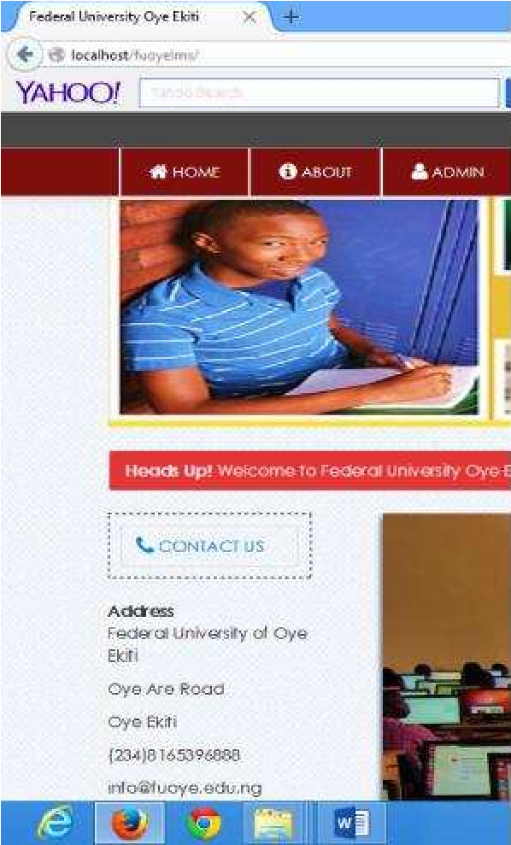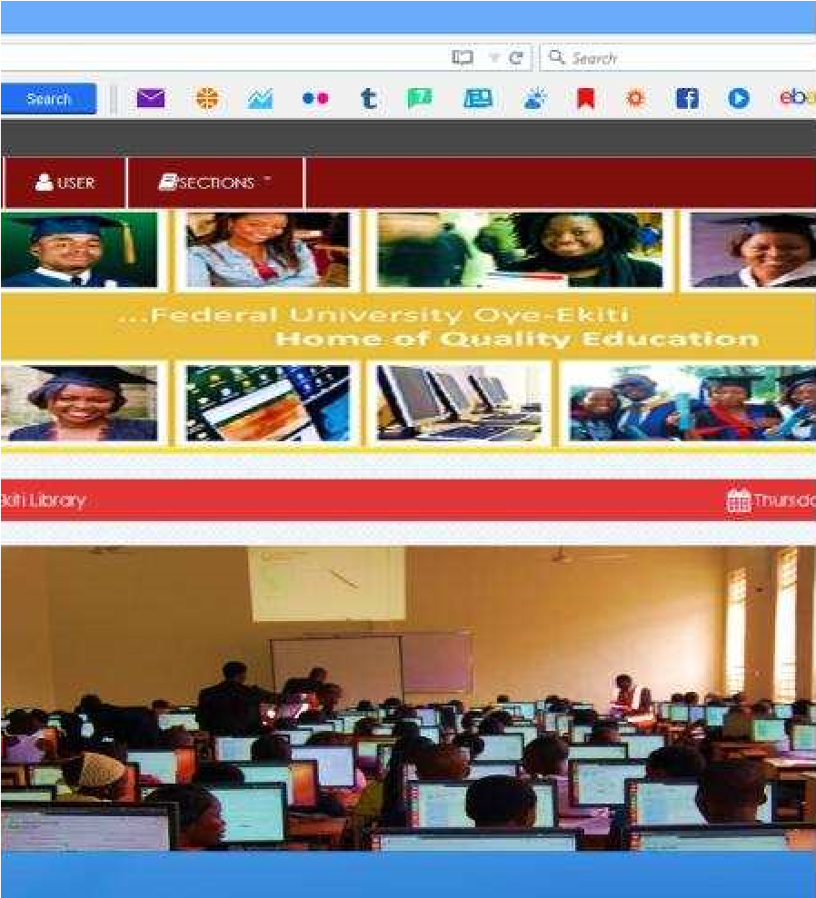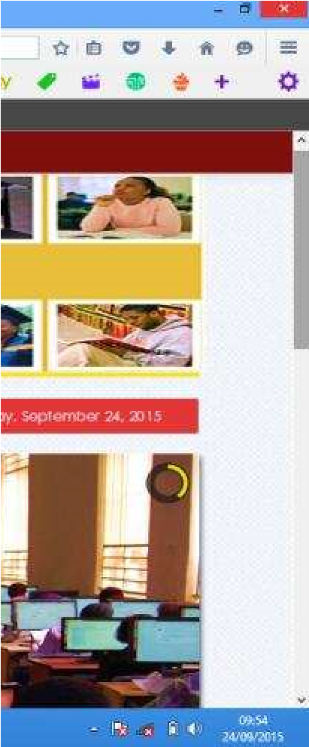

Figure 4.1: screenshot for homepage

#### 4.5.2 Admin/User Login

For the admin login, the admin can log in with his /her own username and password while for the user login, a given user must have to be registered before getting the access to have the username and password to use the library.

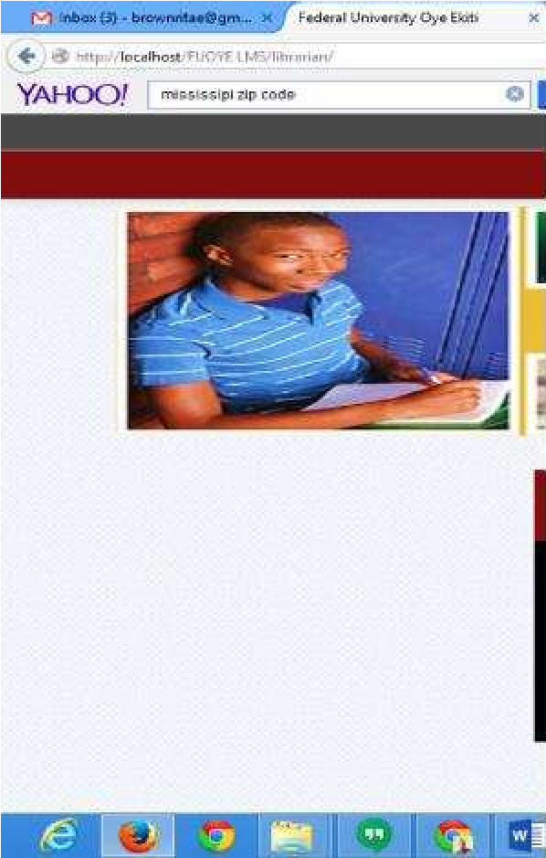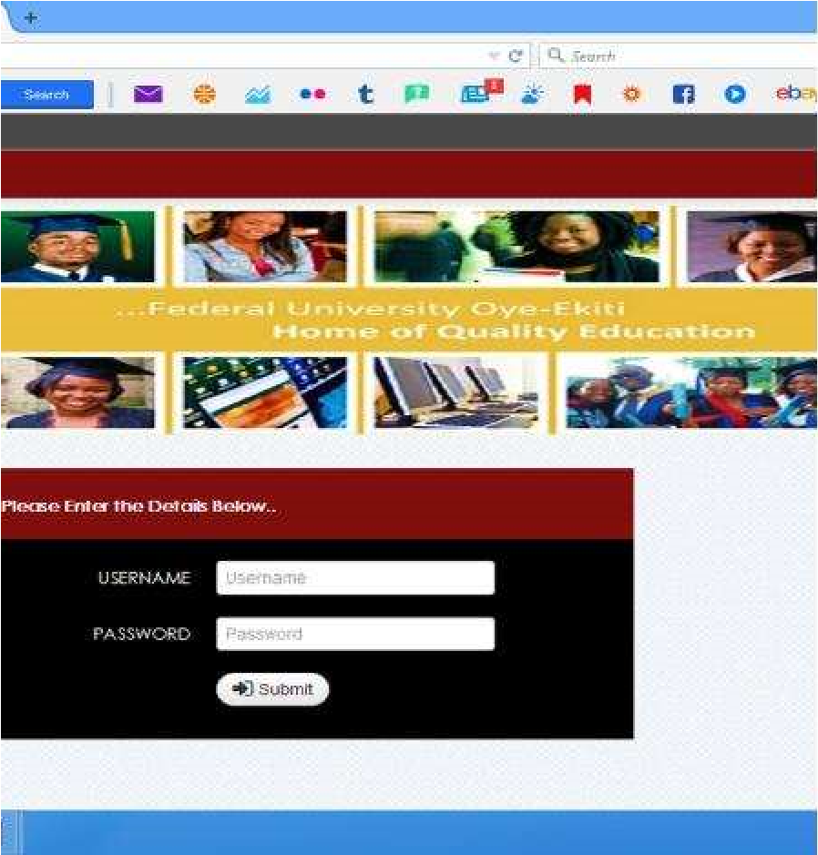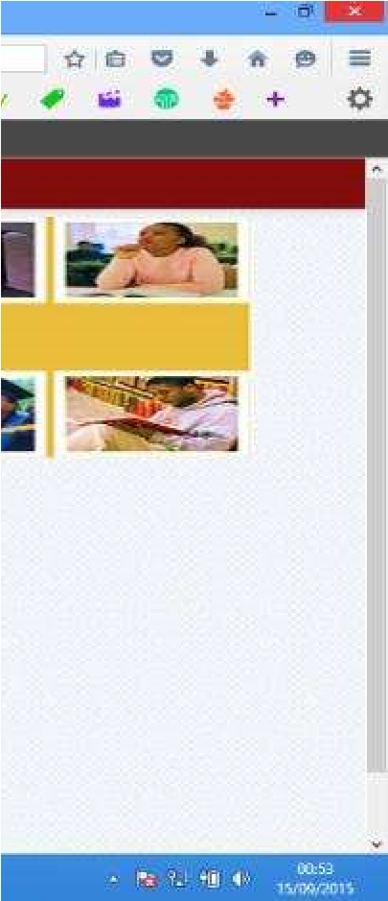

Figure 4.2: screenshot for admin/user login

#### 4.5.3 Add Books

Here, only the admin has the authorized access to add a particular book to the library shelf. The user has no access to this. The library admin more like the librarian can add new books to the library as much as possible for the user to borrow and use.

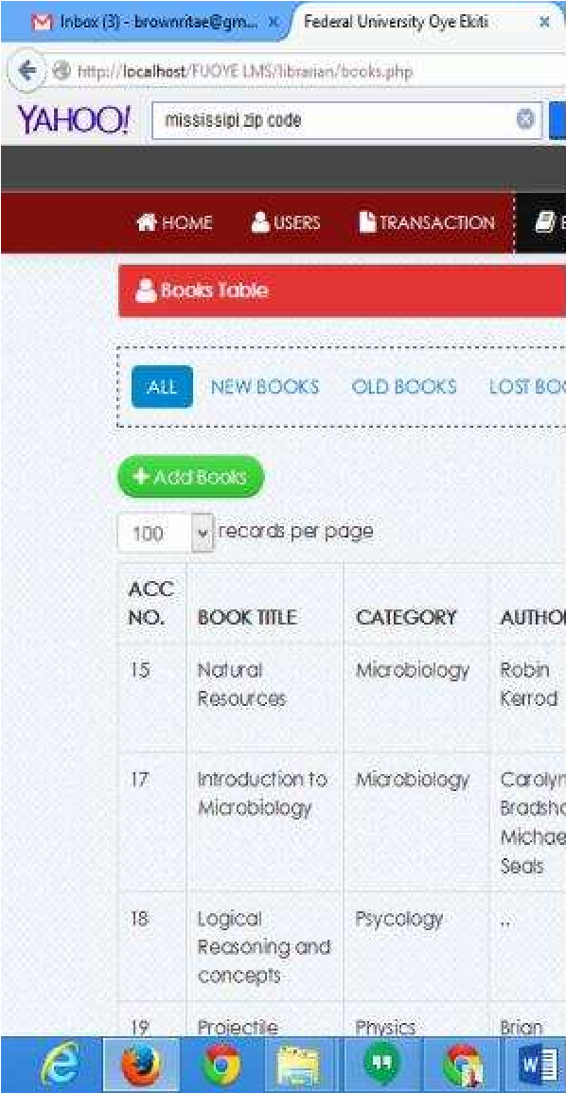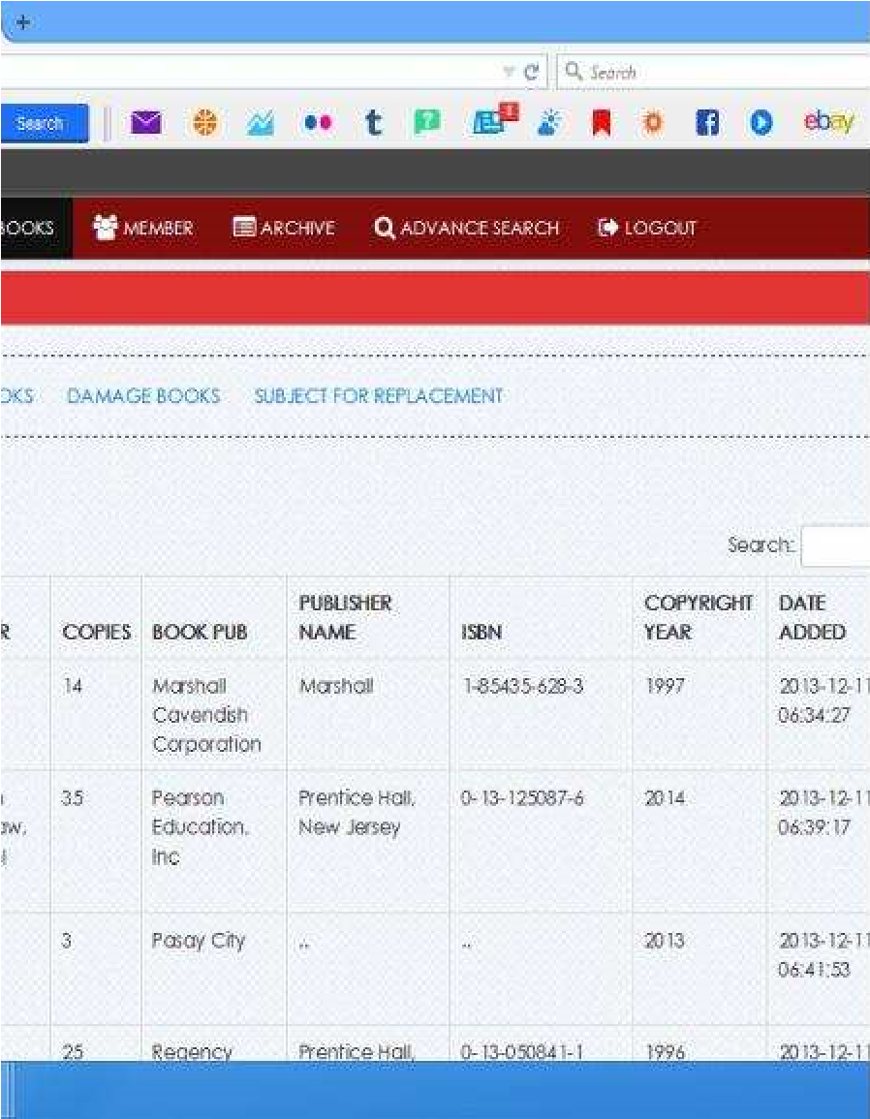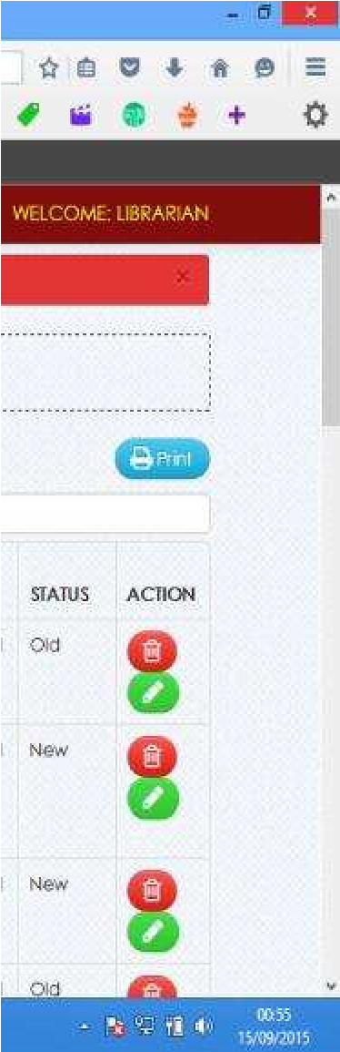

Figure 4.3: screenshot for add books.

#### 4.5.4 Add User

Here the admin can add a new user of the library, by registering the user needed information to use the library. Information such as the username, required password, matriculation number, department and level are required by the admin from the user to get registered as a library user.

After being added as a user, the user can then have his/her login such as the username and password to get access to the library system.

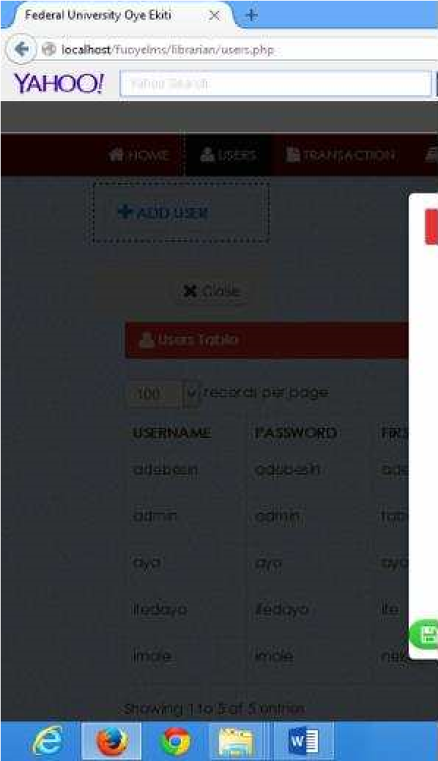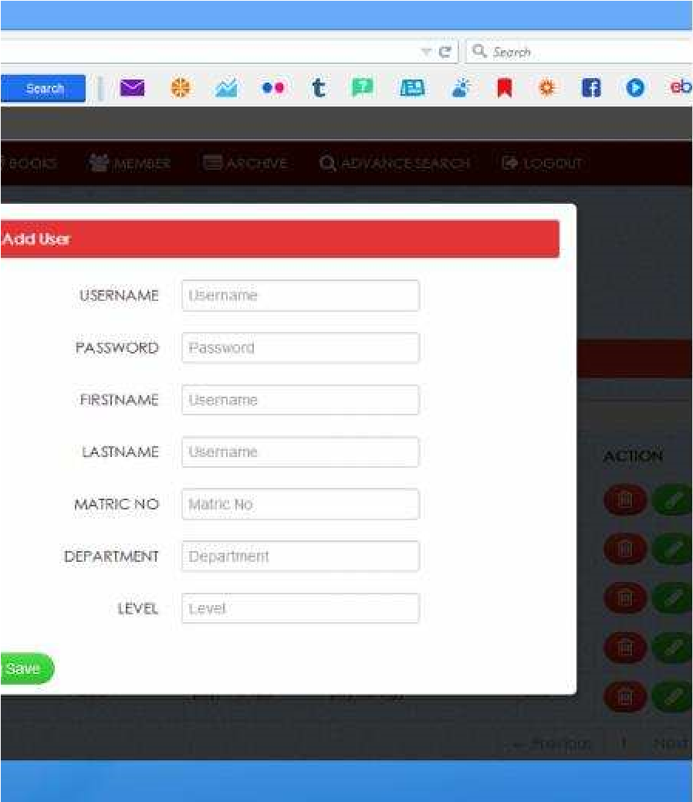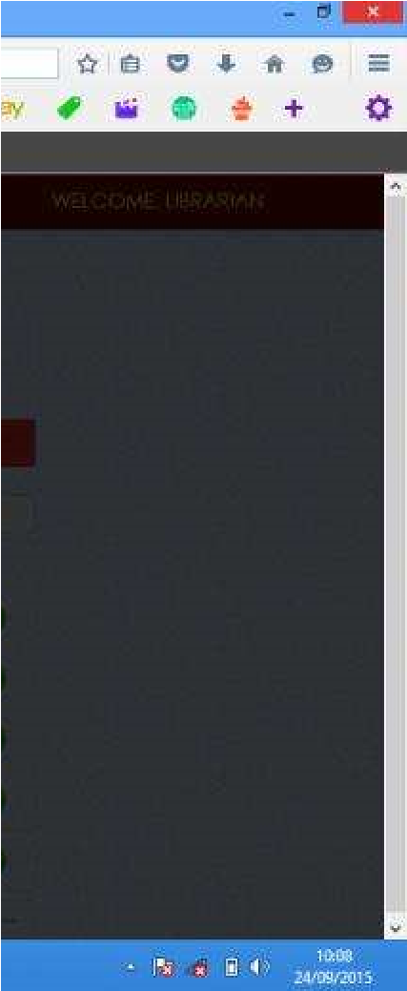

Figure 4.4: screenshot for add user.

#### 4.5.5 Book Borrow

Here the user of the library after being registered can borrow a particular book in the library.

A user of the library is restricted to borrowing only three books at a time.

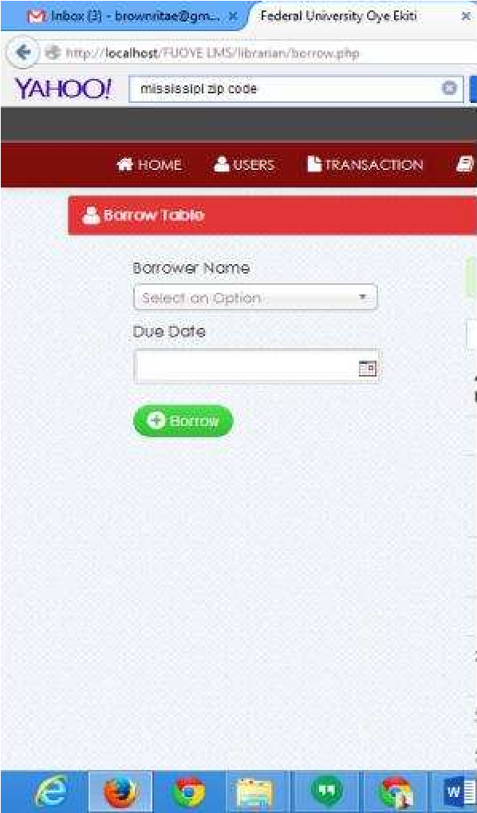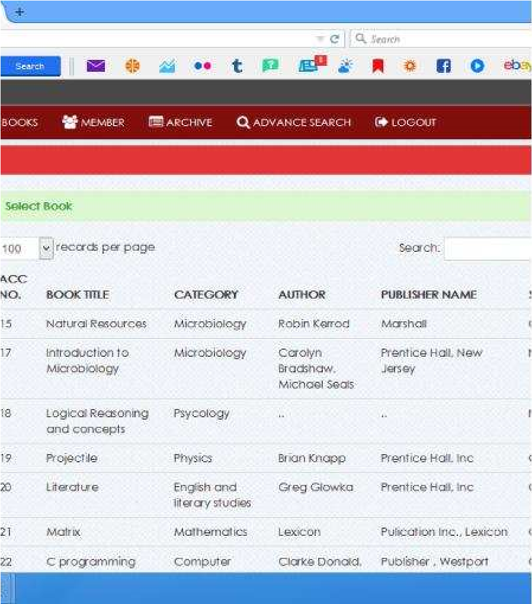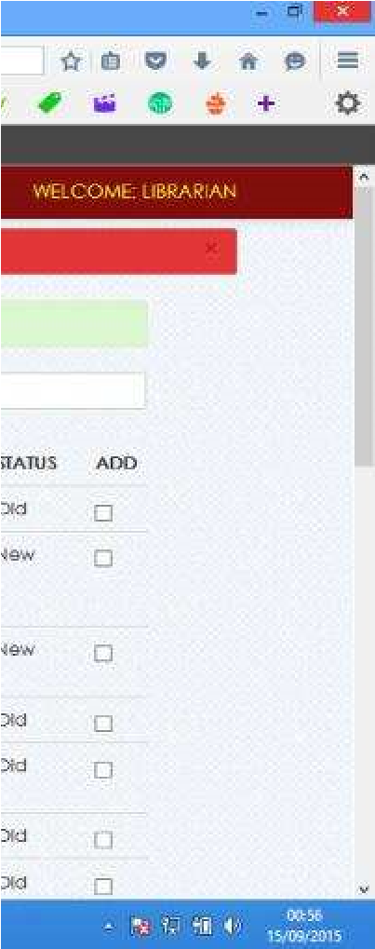

Figure 4.5: Screenshot for book borrow.

### 4.6 Database Design

This refers to the tables used in the proposed system. The database design for the proposed system is as shown below.

#### 4.6.1 User Table

The user table entails the user id, username, password, first name, last name, matriculation number, department and level.

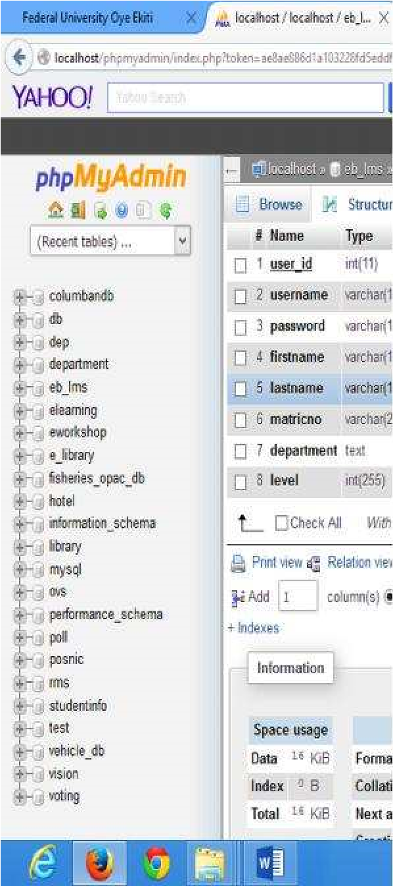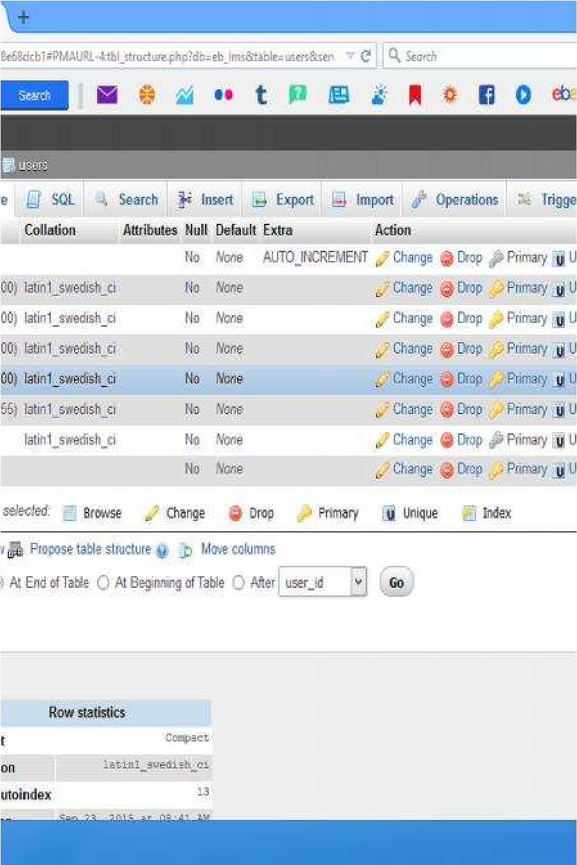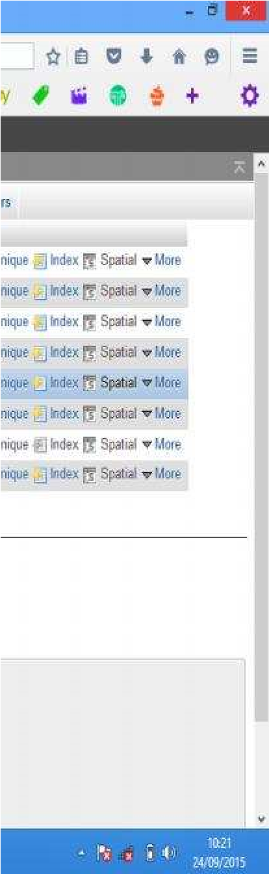

Figure 4.6: screenshot for user table.

## 4.6.2Borrow Details table

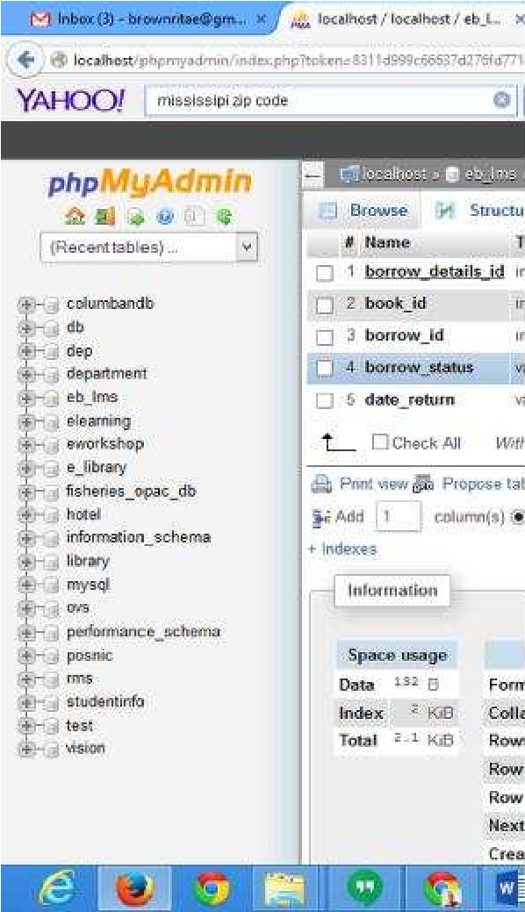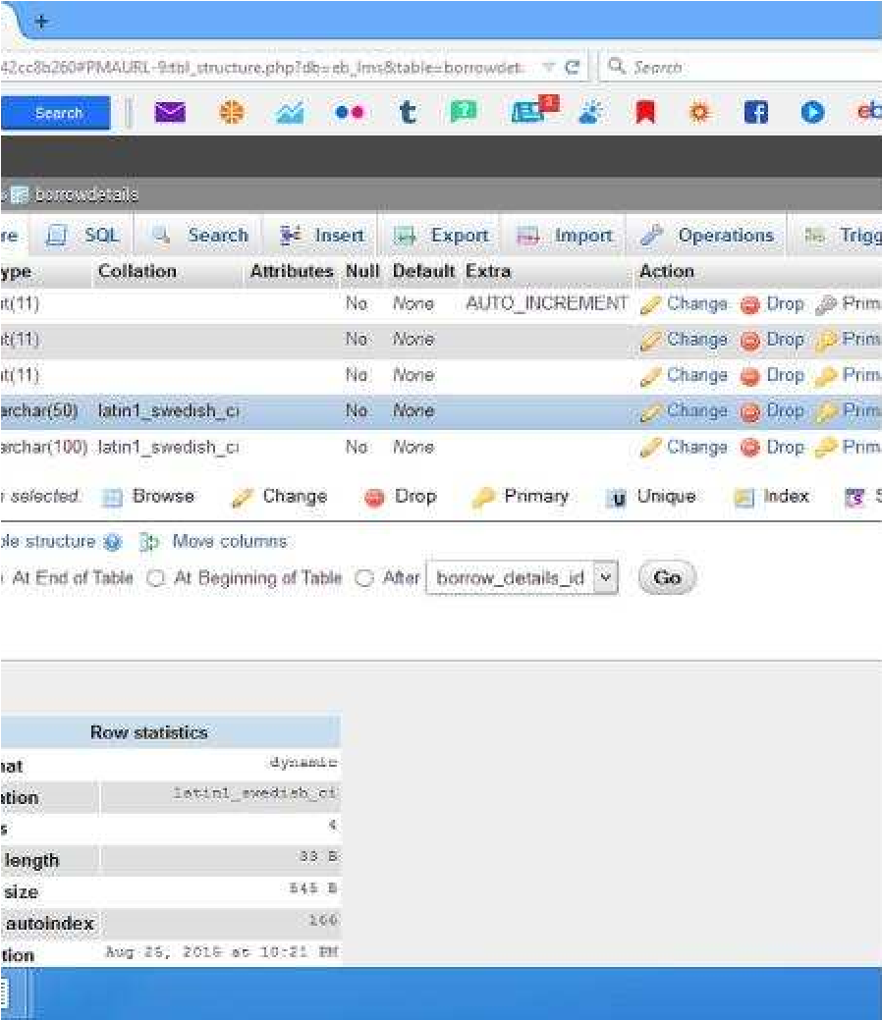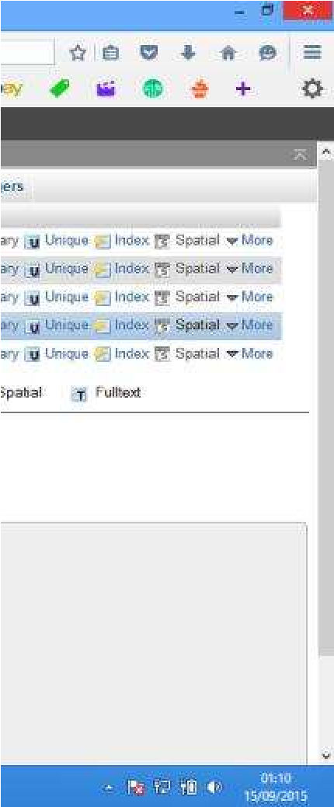

Figure 4.7: screenshot for borrow details.

### 4.6.3 Book table

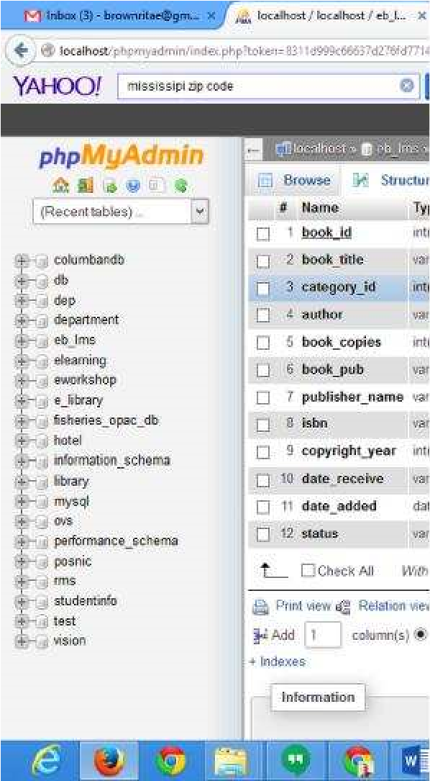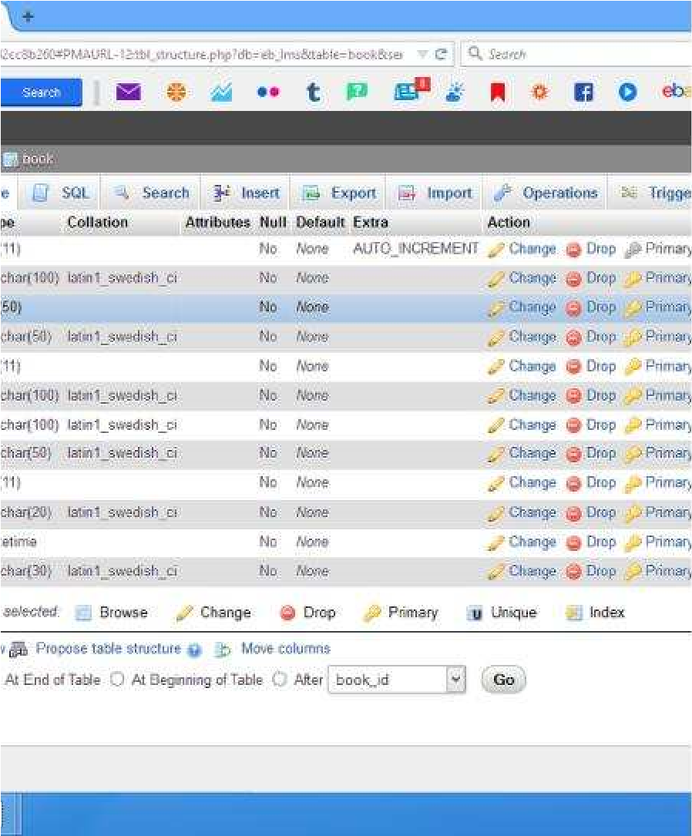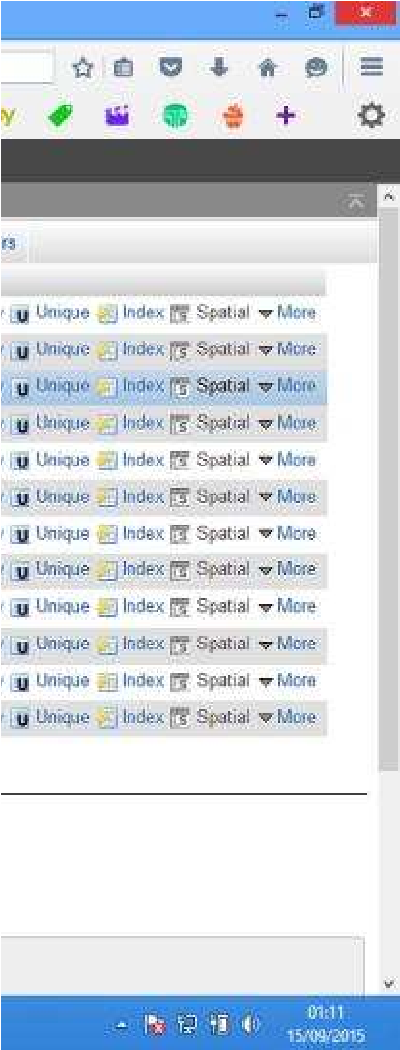

Figure 4.8: screenshot for book table.

### 4.6.4 Member table

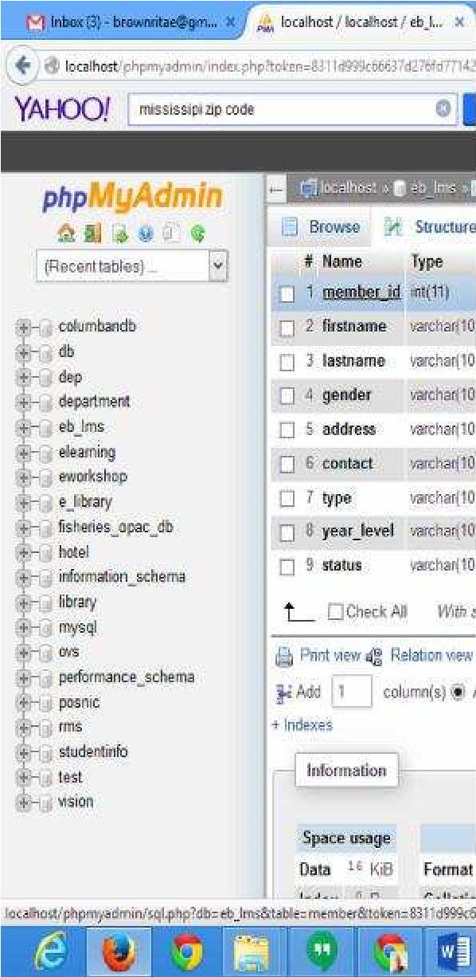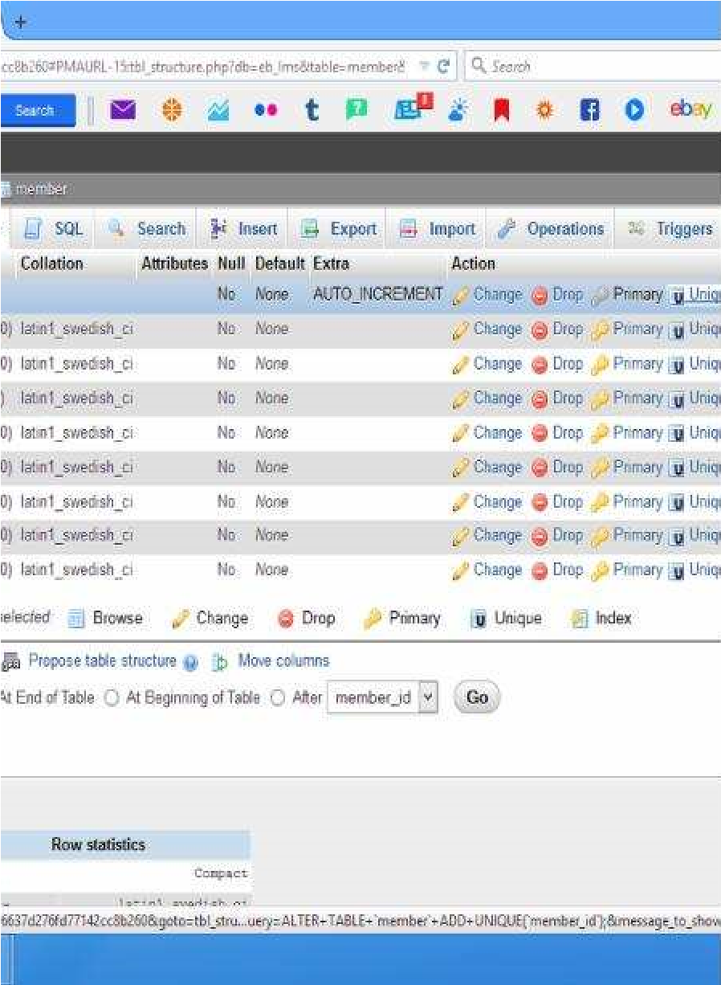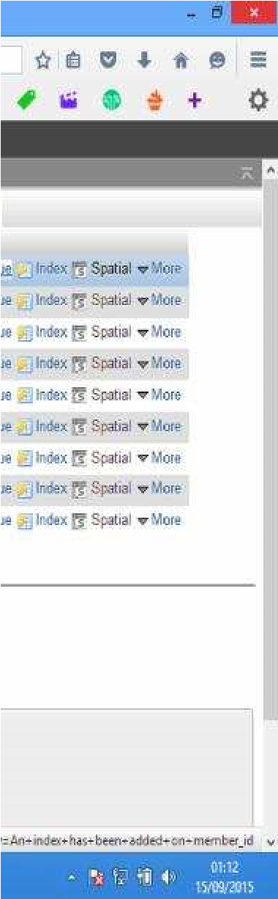

Figure 4.9: screenshot for member table.

**CHAPTER FIVE**

# 5.0 SUMMARY, CONCLUSION AND RECOMMENDATION 5.1 Summary

The quest to make life easier and processing faster has led to computerization of various processes. Computer technology has transformed so many sectors especially the educational sector in no small measure. To foster technology driven education, a Library Management System has been developed to manage all library operations such as borrowing, returning of books etc.

## 5.2 Conclusion

In conclusion, from proper analysis and assessment of the designed system it can be safely concluded that the system is an efficient, usable and reliable Library Management System. It is working properly and adequately meets the minimum expectations that were for it initially. The new system is expected to give benefits to the users and staff in terms of efficiency in the usage of library system.

## 5.3 Recommendation

For further research work to be carried out. I hereby suggest the following.

1. University Library should be developed to work on any platform.
2. Diagrammatic representation as a lecturing aid should be included in

aUniversityLibrary.

1. University library lecturing should also be extended to other field of study such as chemistry, English Biology Agricultural science and many others.
2. University library should be developed to support audio, video and a diagrammatic aid to learning.

# REFERENCES

Adamson and Veronica. (2008). JISC & SCONUL Library Management Systems Study. Sheffield, UK: Sero Consulting. p. 51. Retrieved on 06 August 2015.

Ademodi, D.T., & Adepoju, E. O. (2009). Computer skill among Librarians in Academic

Libraries on Ondo and Ekiti States, Nigeria. Library Philosophy & Practice.

Adomi, E. E., & Anie, S. O. (2006). An Assessment of Computer Literacy Skills of Professionals in Nigerian University libraries. Library Hi Tech News, Vol.23 (2) pp.10-14.

Ashutosh, T and Ashish, S. (2012). Online Library Management System. IOSR Journal of

Engineering (IOSRJEN). Vol. 2 (2), pp. 180- 186.

Dasgupta, A. (2009). Preparing future librarians in India: A vision for LIS Schools of Indian

Universities in the 21st Century. IFLA. Available:

http://www.ifla.org/files/hq/papers/ifla75/126-dasgupta-en.pdf.

DeSpautz, Joseph; Kenneth S. Kovacs; Gerhard Werling (2008). GAMP Standards for Validation of Automated Systems. Pharmaceutical Processing. Retrieved 28 February 2012.

Dinesh, R., Pravin, S., Aravindhan, M and Rajeswari, D. 2015. Library access system Smartphone Application using Android. International Journal of Computer Science and Mobile Computing. Vol.4 (3), pp. 142-149.

Gavgani, V.Z., Shokraneh, F. and Shiramin, A.R. (2011). Need for content Re-engineering of the medical library and information science curriculum in Iran. Library Philosophy &

Practice. Available: http://unllib.unl.edu/LPP/gavgani- shokraneh-shiramin.html.

Johnson, C.A. (2007). Library and information science education in developing countries. The

International Information & Library Review, Vol. 39, pp. 64-71.

Neelakandan, B., Duraisekar, S., Balasubramani, R and Srinivasa, S. 2010. Implementation of

Automated Library Management System in the School of Chemistry Bharathidasan

University using Koha Open-Source Software. International Journal of Applied Engineering Research, Dindigul, Vol. (1), pp. 149-167.

Prabhakar kumar, Rahul Kumar, Rajat Singh and Vikram Singh. (2014). Library Management System. Division of Computer Science School of Engineering Cochin University of Science & Technology Kochi-682022.

Rahman, A. I. M. J., Khatun, M., & Islam, M. M. (2008). Library Education in Bangladesh: Strengths, Problems and Suggestions. Library Philosophy & Practice. Available: http://unllib.unl.edu/LPP/rahman-khatun-mezbahulislam.html.

Sarawut Markchit. (2015). Offering Library Resources through Website and Mobile Systems with Web Services for Central Library Suratthani Rajabhat University.World Journal of Computer Application and Technology, Vol.3 (1) pp. 1-8.

Sarawut Markchit. (2015). Library management system. Division of computer science school of arts and science Tanku Abdul Rahman College Kuala Lampur**.**

Sharma, C.K., Singh and Khiran. (2005). Library Management System. Available: en. wkipedia.

org/wiki/Library management.

Siwakoti, S. (2008). Status of school library development in Nepal. Sri Lanka Journal of Librarianship & Information Management, Vol.1 (1), pp.13-19. Available:

http://www.cmb.ac.lk/academic/institutes/nilis/reports/Nepal.pdf.

**APPENDIX: CODE**

# Index code

<?php include('header.php')?>

<?php include('navbar.php')?>

<div class="container">

<div class="margin-top">

<div class="row">

<?php include('head.php')?>

<div class="span2">

<?php include('sidebar.php'); ?>

</div>

<div class="span10">

<?php include('slider.php');?>

</div>

<div class="span2">

<h4></h4>

</div>

<div class="span10">

<?php include('thumbnail.php')?>

<div class="text_content">

<div class="abc">

<! -- text content -->

<h4>Vision</h4>

<hr>

<p>

The Dominion University College aspires to become an

institution of first choice recognised for providing critical opportunities for student success, acknowledged as a primary and engaged regional and global resource for entrepreneurial education and best practise in mining and farming technology.

</p>

<hr>

<h4>Mission</h4>

<hr>

<p>

To provide a robust and high quality educational

experience for students in a diverse learning environment while promoting the values and indigenous learning that is responsive to the needs of our society and create institutional values.

</p>

<hr>

</div>

</div>

<! -- end content -->

</div>

</div>

</div>

</div>

<?php include('footer.php')?>

**Header**

<!DOCTYPE html>

<html>

<head>

<title>Dominion University College</title>

<meta name="viewport" content="width=device-width, initial-scale=1.0">

<! -- Bootstrap -->

<link href="css/bootstrap.css" rel="stylesheet" media="screen">

<link href="css/bootstrap-responsive.css" rel="stylesheet"

media="screen">

<link href="css/docs.css" rel="stylesheet" media="screen">

<link href="css/diapo.css" rel="stylesheet" media="screen">

<link href="css/font-awesome.css" rel="stylesheet" media="screen">

<link rel="stylesheet" type="text/css" href="css/style.css" />

<link rel="stylesheet" type="text/css" href="css/DT_bootstrap.css" />

<!-- js -->

<script src="js/jquery-1.7.2.min.js"></script>

<script src="js/bootstrap.js"></script>

<script src="js/jquery.hoverdir.js"></script>

<script type="text/javascript" charset="utf-8" language="javascript"

src="js/jquery.dataTables.js"></script>

<script type="text/javascript" charset="utf-8" language="javascript" src="js/DT_bootstrap.js"></script>

<script> jQuery(document). ready (function () {

$(function () {

$(‘. pix_diapo'). diapo ().

}).

}).

</script>

<noscript>

<style>

. da-thumbs li a div {top: 0px; left: -100%.

-webkit-transition: all 0.3s ease.

-moz-transition: all 0.3s ease-in-out;

-o-transition: all 0.3s ease-in-out;

-ms-transition: all 0.3s ease-in-out; transition: all 0.3s ease-in-out;

}

.da-thumbs li a:hover div{ left: 0px;

}

</style>

</noscript>

</head>

<body>

**Navbar**

<?php include('tooltip.php')?>

<div class="navbar navbar-fixed-top navbar-inverse">

<div class="navbar-inner">

<div class="container">

<a class="btn btn-navbar" data-toggle="collapse" data-target=".nav-collapse">

<span class="icon-bar"></span>

<span class="icon-bar"></span> <span class="icon-bar"></span>

</a>

<div class="nav-collapse collapse">

<ul class="nav">

<li class="divider-vertical"></li><li class=""><a

rel="tooltip" data-placement="bottom" title="Home" id="home" href="index.php"><i class="icon-home icon-large"></i>&nbsp;Home</a></li>

<li class="divider-vertical"></li>

<li class="">

<a rel="tooltip" data-placement="bottom" title="Click Here to About" id="login" href="about.php"><i class="icon-info-sign iconlarge"></i>&nbsp;About</a>

<li class="divider-vertical"></li>

<li class="">

<a rel="tooltip" data-placement="bottom" title="Click

Here to Admin" id="login" href="librarian"><i class="icon-user iconlarge"></i>&nbsp;Admin</a>

</li>

<li class="divider-vertical"></li>

<li class="">

<a rel="tooltip" data-placement="bottom" title="Click Here to User" id="login" href="user"><i class="icon-user icon-large"></i>&nbsp;User</a>

</li>

<li class="divider-vertical"></li>

<li class="dropdown">

<a href="#" class="dropdown-toggle" data-toggle="dropdown">

<i class="icon-book icon-large"></i>&nbsp;Sections

<b class="caret"></b>

</a>

<ul class="dropdown-menu">

<li><a href="circulation section.php"><i class="icon-search icon-large"></i>Circulation Section</a></li>

<li><a href="Periodical section.php"><i class="icon-search icon-large"></i>Periodical Section</a></li>

<li><a href="Audio-Visual section.php"><i class="icon-search icon-large"></i>AudioVisual Section</a></li>

<li><a href="General Reference section.php"><i class="icon-search iconlarge"></i>General Reference Section</a></li>

<li><a href="Faculty reading.php"><i class="icon-search icon-large"></i>Faculty Reading Section</a></li>

<li><a href="Archive section.php"><i class="icon-search icon-large"></i>Archive Section</a></li>

<li><a href="American shelf.php"><i class="icon-search icon-

large"></i>American</a></li>

</ul>

</li>

<li class="divider-vertical"></li>

<li class="signup"><span class="sg"></span></li>

</ul>

</div>

</div>

</div>

</div>

**Head**

<div class="span12">

<div class="header">

<div class="pull-left">

<img class="stilogo" src="LMS/A1.jpg">

</div>

</div>

<div class="alert alert-info"><Strong>Heads Up!</strong>&nbsp;Welcome to Dominion University College Library

<div class="pull-right">

<i class="icon-calendar icon-

large"></i> <?php

$Today = date('y:m:d');

$new = date('l, F d, Y',

strtotime($Today));

echo $new;

?>

</div>

</div>

</div>

**Sidebar**

<div class="life-side-bar">

<div class="hero-container">

</div>

<ul class="nav nav-tabs nav-stacked">

<li class="">

<a href="#"><i class="icon-phone icon-

large"></i>&nbsp;Contact US</a>

</li>

</ul>

<strong>Address</strong>

<p>Dominion University college</p>

<p>Bawaleshie Are Road</p>

<p>Accra</p>

<p>(233)200180247</p>

<p>info@duc.edu.gh</p>

</div>

<!-- vision student login -->

<div id="vision" class="modal hide fade" tabindex="-1" role="dialog" arialabelledby="myModalLabel" aria-hidden="true">

<div class="modal-header"><div class="alert alert-

info"><strong>Vision</strong></div></div>

<div class="modal-body">

<p>By 2022. Dominion University College is a center of learning were

stackholders are conscientiously involved in loning holistic

individuals committed to positively respond to the

needs of the school, community and the country.</p>

</div>

<div class="modal-footer">

<button class="btn" data-dismiss="modal" aria-hidden="true"><i

class="icon-remove icon-large"></i>&nbsp;Close</button>

</div>

</div> <!-- mission student login -->

<div id="mission" class="modal hide fade" tabindex="-1" role="dialog" arialabelledby="myModalLabel" aria-hidden="true">

<div class="modal-header"><div class="alert alert-

info"><strong>Mission</strong></div></div>

<div class="modal-body">

<p>

To nurture students to become productive responsible citizens through the

assistance of service -

oriented and highly competent internal and external stakeholders working in a

harmonious relationship.

</p>

</div>

<div class="modal-footer">

<button class="btn" data-dismiss="modal" aria-hidden="true"><i

class="icon-remove icon-large"></i>&nbsp;Close</button>

</div>

</div>

**Footer**

<footer class="footer">

<div class="container">

<div class="foot-margin">

<p><a>2022 Dominion University College. All Rights Reserved. </a></p>

</div>

</div>

</footer>

<script type="text/javascript">

$(function() {

$('#da-thumbs > li').hoverdir();

});

</script>

<div id="logout" class="modal hide fade" tabindex="-1" role="dialog" arialabelledby="myModalLabel" aria-hidden="true">

<div class="modal-body">

<div class="alert alert-danger">Are you sure you want to Logout</div>

</div>

<div class="modal-footer">

<button class="btn" data-dismiss="modal" aria-hidden="true">Close</button>

<a href="logout.php" class="btn btn-danger">Yes</a>

</div>

</div>

<script type='text/javascript' src='scripts/jquery.easing.1.3.js'></script>

<script type='text/javascript' src='scripts/jquery.hoverIntent.minified.js'></script> <script type='text/javascript' src='scripts/diapo.js'></script>

</body>

</html>